Geography: Stage 3 (Years 5 and 6) A Diverse and Connected World
Students explore countries of the Asia region and the connections Australia has with other countries across the world. Students learn about the diversity of the world’s people, including the indigenous peoples of other countries. Students will explore and reflect upon similarities, differences and the importance of intercultural understanding.
Topic: | Connections shape perceptions: Perceptions of Papua New Guinea
Key inquiry questions: | How do people’s connections to places affect their perception of them?
Content
Connections shape perceptions
Students:
- investigate how connections influence people’s perception and understanding of places, for example: (ACHGK036)
- identification of factors that influence people’s perceptions of places eg media, culture, education, travel
- discussion of the effect of generalisations and stereotypes about places

Student Learning Activities
Activity 1: Engagement  Study the flag of Papua New Guinea and, with a partner, answer the following questions:  Observe  What symbols have been used?  What colours are used?  How is it similar to the Australian flag?  Infer  What do you think the symbols represent?  What do you think the colours represent?  Prior knowledge  With a partner, students share their knowledge and understanding of the natural landscapes, people and culture of Papua New Guinea. They complete the Knowledge column of Table 1. | Source 1: Flag of Papua New Guinea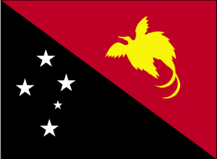  Public domain https://commons.wikimedia.org/wiki/File:Papua_new_guinea_flag_large.png?uselang=en-gb

TABLE 1 – NATURAL AND HUMAN FEATURES OF PAPUA NEW GUINEA
 | Knowledge – what I know | Learnt – what I’ve learnt
Natural features
Vegetation
Native animals
Landscape
Climate / weather
Human features
People
Cultural traditions
Housing
Education
Health
Transport
Industry

Activity 2: Formulate questions for inquiry
- How are our perceptions and understandings of Papua New Guinea formed and developed?
- What factors influence our perception and understanding?
- How can we challenge stereotypical thinking and generalisations about the people and places of Papua New Guinea?

Activity 3: Acquiring and representing geographical information – Formulating ideas about Papua New Guinea
a. As a class view Source 1 and Source 2. Source 1 is a video from ABC Television’s Behind the News about Papua New Guinea’s celebration of 40 years of Independence. Source 2 is a World Vision production which examines health and well being in Papua New Guinea. Use the questions to guide discussion.
Source 1: ABC TV Behind the News – PNG Independence http://www.abc.net.au/btn/story/s4309028.htm  Source 2: World Vision country profile and health scenario  https://www.youtube.com/watch?v=d2yC8oOyTZc | What organisation has made each video?  Who is the audience of each video?  What information is presented in each video?  What language is used to describe the people and issues of Papua New Guinea? Is it persuasive? Does it alter your perceptions?  How do each video make you feel?  How would a young person of Papua New Guinea feel after watching each video?

b. Students analyse Sources 3 to 10 that present different aspects of the natural and human features of Papua New Guinea from 1849 to the present day. Students record their observations into Table 2. They then complete Column 2 in Table 1.
Source 3: Image from The Voyage of the HMS Rattlesnake 1849. Full collection: http://www.sl.nsw.gov.au/discover_collections/society_art/png/rattlesnake/index.html  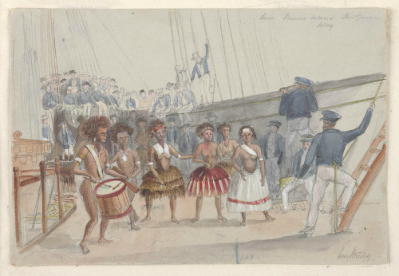  http://www.acmssearch.sl.nsw.gov.au/search/itemDetailPaged.cgi?itemID=423863 |  | Source 4: Ellis Silas collection 1922–1924. In 1922 Ellis Silas travelled to the Trobriand Islands in Papua New Guinea where he lived and painted for 2 years. Collection of his Papua New Guinea paintings: http://www.sl.nsw.gov.au/discover_collections/society_art/png/silas/index.html  http://www.sl.nsw.gov.au/discover_collections/society_art/png/silas/silas_albumviewer/index.html
Source 5: Stills from the film ‘Assault on Salamaua’ by Damien Parer, 1943. During the Pacific War, Australian soldiers fought against the Japanese Imperial Army in the battlefields of Papua New Guinea. Parer captured the action for the Department of Information.  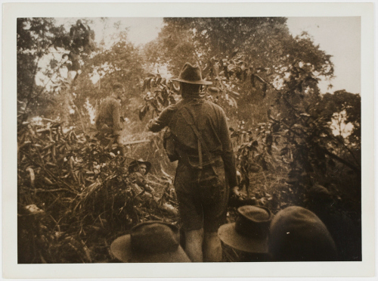  http://www.acmssearch.sl.nsw.gov.au/search/itemDetailPaged.cgi?itemID=1064173 |  | Source 6: Male Marqui de Ragi’s Bird of Paradise, female on the left, by John Gould (1804-1881) in The Birds of New Guinea and the Adjacent Papuan Islands.  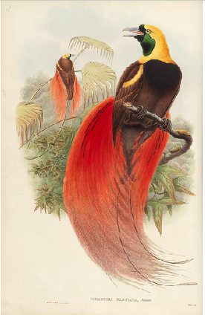  http://www.sl.nsw.gov.au/discover_collections/society_art/png/birds/index.html
Source 7: Western Provence, 2011. An Australian doctor working for Australian Doctors International arrives into a remote village. Delivery and accessibility to health services is difficult with few roads and river and air travel being expensive. A temporary medical clinic will be established and people will get access to medical care.  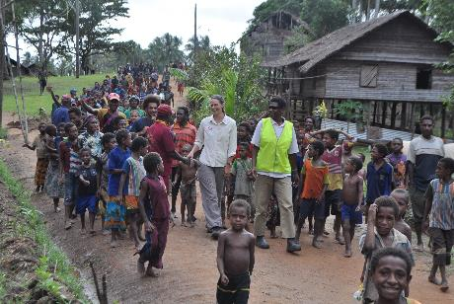  Photo: Australian Doctors International, with permission | Source 8: Remote village in the highlands of Papua New Guinea, 2011. The climate is characterised as having high temperatures and high humidity with high rainfall. In the highlands annual rainfall varies between 2 000 and 5 000mm.  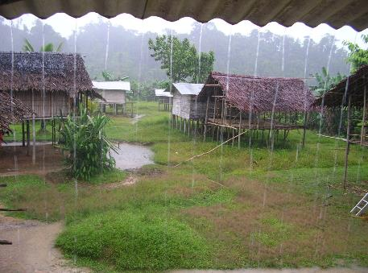  Photo: Australian Doctors International, with permission

Source 9: New Ireland Province, 2012. This province is an island located northeast of mainland Papua New Guinea. The traditional Malagan culture of this region features many ceremonies and customary practices.  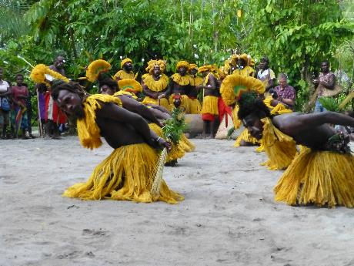  Photo: Australian Doctors International, with permission | Source 10: New Ireland, Papua New Guinea, 2010. The children are using a water tap for the first time in. Lack of access to clean drinking water and sanitation can lead to water based diseases such as diarrhea, cholera and typhoid, a major contributing factor to high mortality rates.  Further information: School Resources: Water based diseases in Papua New Guinea by WorldVision Aus https://www.youtube.com/watch?v=IzzRoY_O49o  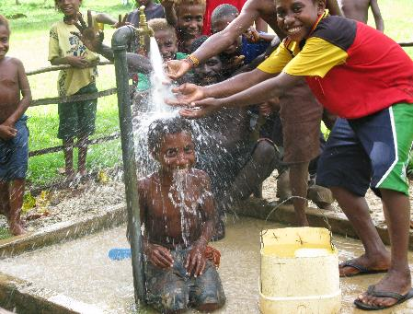  Photo: Australian Doctors International, with permission

TABLE 2 – PAPUA NEW GUINEA SOURCE ANALYSIS
Source | Date and maker | Natural features | Human features and / or story | What message does the author wish to convey in the image? | How effective is this source at enhancing your understanding?
Source | Date and maker | Natural features | Human features and / or story | What message does the author wish to convey in the image? | How effective is this source at enhancing your understanding?
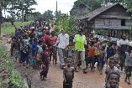
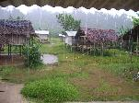
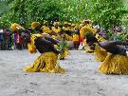
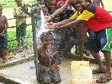
Activity 4: Acquiring and representing geographical information – Flag of Papua New Guinea
Use the questions to guide research the story of Susan Karike, the fifteen year old girl who created the Flag of Papua New Guinea. Explain the symbolism in the flag and describe how you think this girl felt about her country.
Source 1:  Public domain https://commons.wikimedia.org/wiki/File:Papua_new_guinea_flag_large.png?uselang=en-gb | Who created this flag?  Why did she use these colours?  What two symbols have been used and why?  How do you think the creator would feel about her country?  What should a flag represent about its country?

Activity 5: Processing geographical information – A partial view
View Sources 11a, 12a and 13a. Consider the bigger picture by completing the questions.
Source 11a:  Photo: Australian International Doctors, with permission | Describe what you see.  Describe what the larger image might be.

Source 12a:  Photo: Australian International Doctors, with permission | Describe what you see.  Describe what the larger image might be.
Source 13a:  Photo: Australian International Doctors, with permission | Describe what you see.  Describe what the larger image might be.

Activity 6: Processing geographical information – The complete picture
Observe the full image and complete the questions.
Source 11b: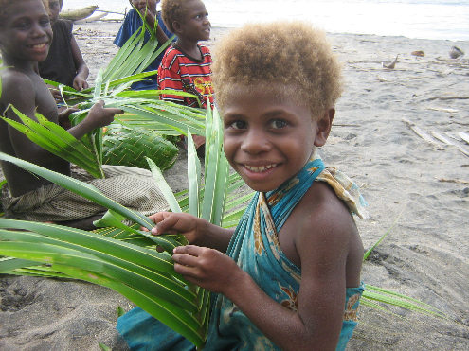  Photo: Australian International Doctors, with permission | How does this full image add to your understanding of the scene?  Describe what might be in an even bigger image of this scene.  How does having the bigger picture alter perceptions and understandings?  Why might people provide only part of a picture?
Source 12b: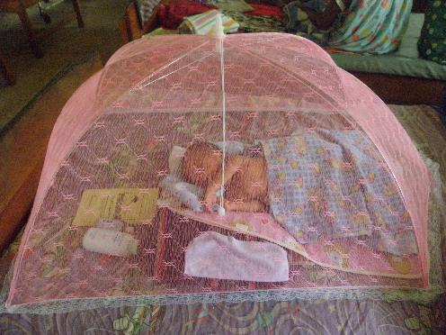  Photo: Australian International Doctors, with permission | How does this full image add to your understanding of the scene?  Describe what might be in an even bigger image of this scene.  How does having the bigger picture alter perceptions and understandings?  Why might people provide only part of a picture?

Source 13b:  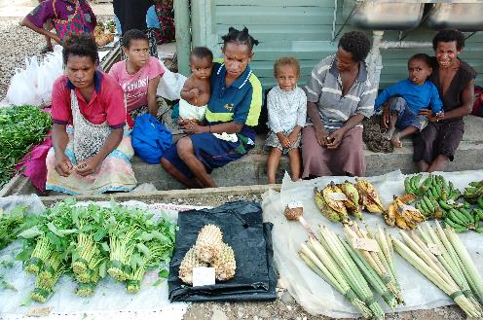  Photo: Australian International Doctors, with permission | How does this full image add to your understanding of the scene?  Describe what might be in an even bigger image of this scene.  How does having the bigger picture alter perceptions and understandings?  Why might people provide only part of a picture?

Activity 7: Communicating – Papua New Guinea flag design
Redesign a new flag for Papua New Guinea. The colours, symbols, positions and design must convey meaning that shows understanding of the country’s people and places and a hope for a better future.
Activity 8: Responding – Connect, learn more, support
Seek out opportunities to speak with young people from Papua New Guinea. Students can do this by contacting schools in Papua New Guinea and establishing an opportunity for electronic communication or through video conferencing.
- Write a list of questions you may like to ask the students.
- Discover what daily life is like in Papua New Guinea and how it is similar or different to our lives in Australia.
- Explore connections between Australia and Papua New Guinea.
Read more about the work of Australian International Doctors (ADI) and the work they do in Papua New Guinea http://www.adi.org.au/
- Write a report about one of the doctors who volunteers in Papua New Guinea. Where are they from? Where did they travel within PNG? How did they get around? What did they do while they were there? Why did they volunteer?
- Consider fundraising for the ADI. Students could run in one of the organised fun runs they offer, create an event with funds going to ADI or raise funds at a stall at school or at a school or community fete.
Background notes for teachers
Natural features of Papua New Guinea
Much of Papua New Guinea remains undeveloped and its natural landscapes relatively untouched. The tropical jungles are high in biodiversity and of world significance. Large numbers of birds, mammals, reptiles, fish, amphibians and invertebrates thrive. It is thought by scientists that many species are yet to be discovered due to the difficulties of reaching isolated and remotes areas.
Travellers throughout history have studied, photographed and painted the natural features of these islands. The Voyage of the Rattlesnake, the paintings by John Gould and Ellis Silas present the islands’ natural features as well as the traditional lives of the people with underlying feelings of awe, wonder and respect. The images from the State Library catalogues showcase the beauty and traditional ways of life of the people of Papua New Guinea.
Papua New Guinea today
Today Papua New Guinea is a developing country that has some of the worst human development indicators in health, education and GNI (living standards). To explore human development indicators further go to http://www.gapminder.org/
The issues facing Papua New Guinea today are complex and difficult. As Australia’s closest neighbour it is in our best interests to help Papua New Guinea develop and prosper into the future. Our two nations are connected through foreign investment and trade, aid and are working towards agreement on environmental and sustainability issues.
It is important that students become aware of the complexity of issues facing development in Papua New Guinea without generalisations and stereotypes. By exploring our connections and understanding how this influences our perceptions and understanding of a place we promote positive values and develop global citizenship in our students.
NSW Syllabus for the Australian Curriculum Geography K–6
Outcomes | Geographical Inquiry Skills | Geographical Concepts
GE3-1 describes the diverse features and characteristics of places and environments  GE3-2 explains interactions and connections between people, places and environments  GE3-4 acquires, processes and communicates geographical information using geographical tools for inquiry | Acquiring geographical information  - develop geographical questions to investigate and plan an inquiry (ACHGS033, ACHGS040)  - collect and record relevant geographical data and information, using ethical protocols, from primary data and secondary information sources, for example, by observing, by interviewing, conducting surveys, or using maps, visual representations, statistical sources and reports, the media or the internet (ACHGS034, ACHGS041)  Processing geographical information  - evaluate sources for their usefulness (ACHGS035, ACHGS042)  - represent data in different forms, for example plans, graphs, tables, sketches and diagrams (ACHGS035, ACHGS042)  - interpret geographical data and information, using digital and spatial technologies as appropriate, and identify spatial distributions, patterns and trends, and infer relationships to draw conclusions (ACHGS037, ACHGS044)  Communicating geographical information  - present findings and ideas in a range of communication forms as appropriate (ACHGS038, ACHGS045)  - reflect on their learning to propose individual and collective action in response to a contemporary geographical challenge and describe the expected effects of their proposal on different groups of people (ACHGS039, ACHGS046) | Place: the significance of places and what they are like eg characteristics of places on a global level.  Environment: the significance of the environment in human life, and the important interrelationships between humans and the environment eg how the environment influences people and places; how people influence the environment; the effect of natural disasters on the environment.  Interconnection: no object of geographical study can be viewed in isolation eg how environments influence where people live; ways people influence the characteristics of their environments; diversity of cultures and peoples around the world.  Scale: the way that geographical phenomena and problems can be examined at different spatial levels eg environmental and human characteristics of places on local, regional and global scales; the effect of global events on people and places locally, regionally and globally.  Change: explaining geographical phenomena by investigating how they have developed over time eg changes to environmental and human characteristics of places.
Learning across the curriculum
- Asia and Australia’s engagement with Asia
- Ethical understanding
- Intercultural understanding
- Critical and creative thinking
- Literacy
- Personal and social capability
- Civics and citizenship
- Difference and diversity
- Work and enterprise
Resources
Picture books
Uno’s Garden by Graeme Base
Bollygum by Garry Fleming
Angel of Kokoda by Mark Wilson
The Lost Tail by Patricia Bernard and Tricia Oktober
The Turtle and the Island by Barabara Ker Wilson, illustrated by Frane Lessac
Websites
Global education – PNG case study and additional links http://www.globaleducation.edu.au/2379.html
Behind the news – PNG Independence segment with additional links http://www.abc.net.au/btn/story/s4309028.htm
Australian Doctors International http://www.adi.org.au/
World Vision http://www.wvi.org/papua-new-guinea
Queensland Museum http://www.qm.qld.gov.au/microsites/celebration-of-culture/explore-png-objects.html

