Stage 2 (Year 3) Community and Remembrance
Students learn about identity and diversity in both a local and broader context. Moving from the heritage of their local area, students explore the historical features and diversity of their community as represented in symbols and emblems of significance, and celebrations and commemorations, both locally and in other places around the world.
Topic: | Sydney - a story of change
Key inquiry question: | How has our community changed? What features have been lost and what features have been retained?
Content
One important example of change over time in the local community, region or state/territory, e.g. transport, work, education, natural and built environment, daily life (ACHHK061)
The history of a significant person, building, site or part of the natural environment in the local community and what it reveals about the past (ACHHK044)
Students:
- brainstorm what aspects of the past can be seen in the local area
- identify a significant building, site or part of the natural environment in the local community and discuss what they reveal about the past and why they are considered important
- investigate an aspect of local history
- develop a narrative on their chosen aspect of local history which focuses on the remains of the past
In this unit of work the term ‘Indigenous’ is used to refer to Aboriginal and Torres Strait Islander people.

Student learning activity
Students use photos and paintings to ask historical questions about the past.
- The activities are designed to introduce students to photos and paintings as historical records of people, places and events in the past.
- Students examine photos and paintings from the State Library of NSW to identify the main features of the cultural landscape of Sydney and describe how Sydney has changed over time.
Activity:
Students:
- look carefully at the images of Sydney
- identify the main geographical and cultural features of the landscape in each image, (e.g. bush, houses, huts, wharves, trees, rocks, cove, buildings, bridge)

Source 1
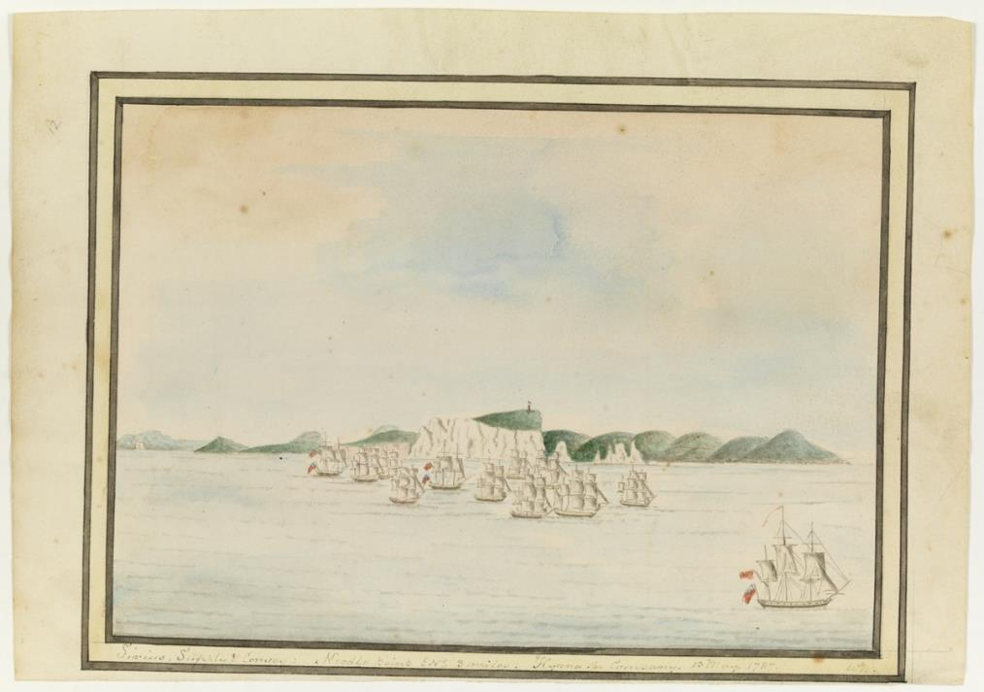
Drawing of Sydney Cove, Port Jackson, 1788 from the journal of William Bradley.
The ship on the left is moored near Bennelong Point and Dawes Point is on the right.
http://www.acmssearch.sl.nsw.gov.au/search/itemLarge.cgi?itemID=894571&size=full&album=1&collection=823705
Source 2
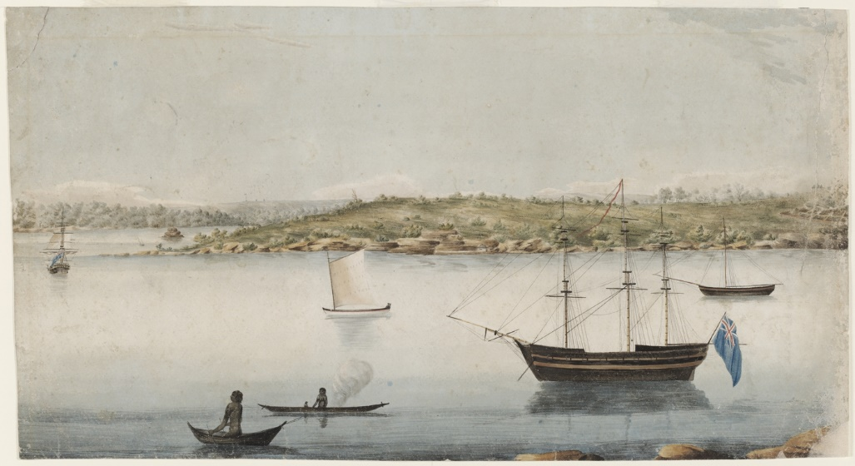
Sydney looking across the harbour towards Bennelong Point from Dawes Point, 1804, by John Eyre
http://www.acmssearch.sl.nsw.gov.au/search/itemDetailPaged.cgi?itemID=845583
Source 3
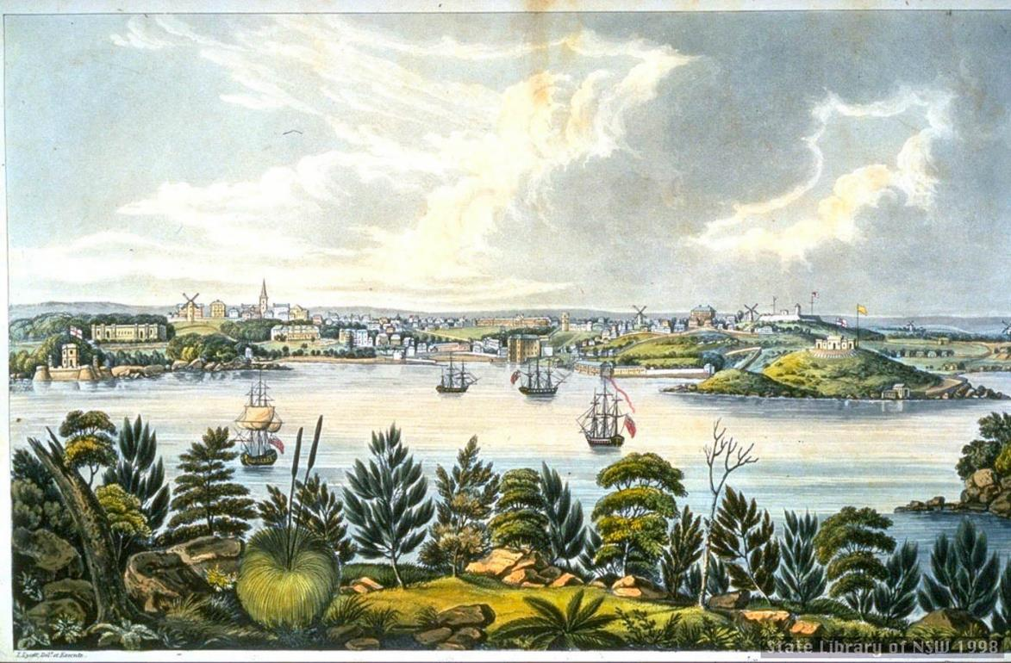
Sydney by Joseph Lycett, 1825, Fort Macquarie (Bennelong Point) on the left and Dawes Point on the right.
http://www.acmssearch.sl.nsw.gov.au/search/itemDetailPaged.cgi?itemID=411398
Source 4
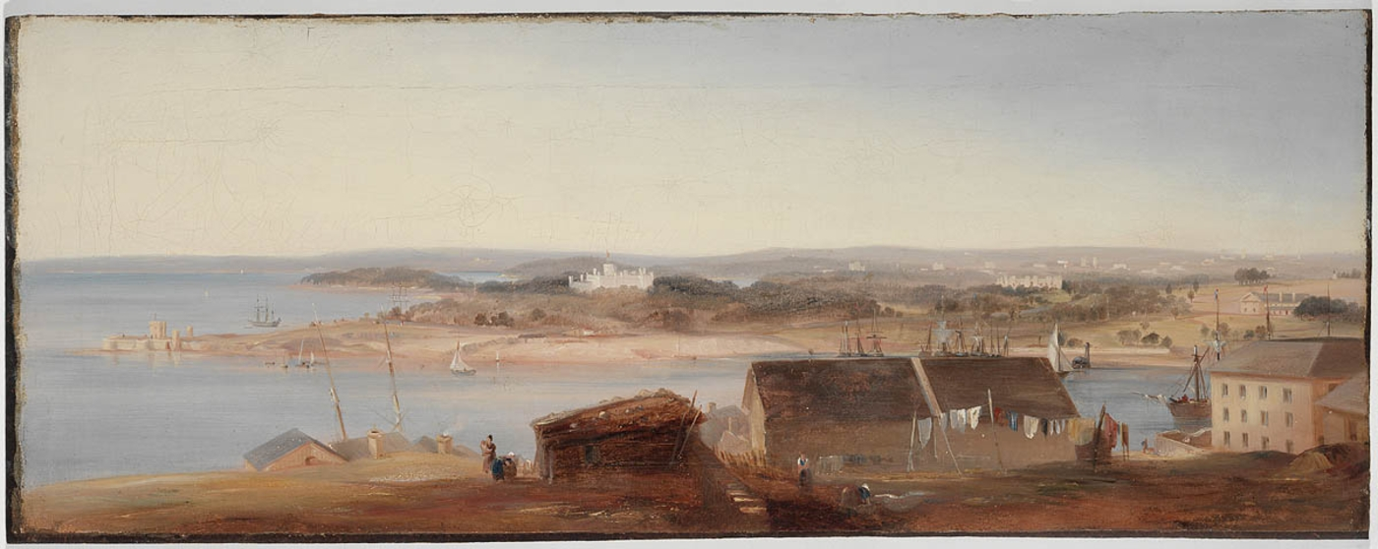
View of Sydney Harbour by Conrad Martens, 1842. Looking across the harbour towards Bennelong Point from Dawes Point.
http://www.acmssearch.sl.nsw.gov.au/search/itemDetailPaged.cgi?itemID=404948

Source 4
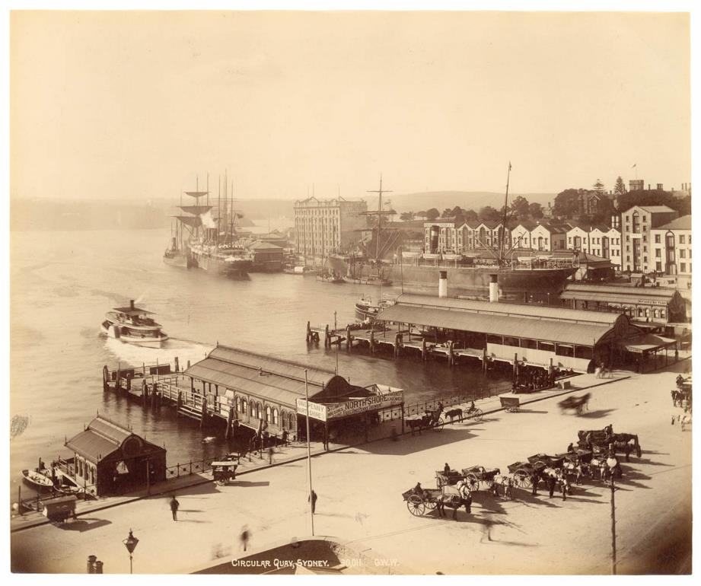
Photo of Circular Quay, Sydney in 1892
http://www.acmssearch.sl.nsw.gov.au/search/itemLarge.cgi?itemID=803591&size=full&album=1&collection=823989
Source 6
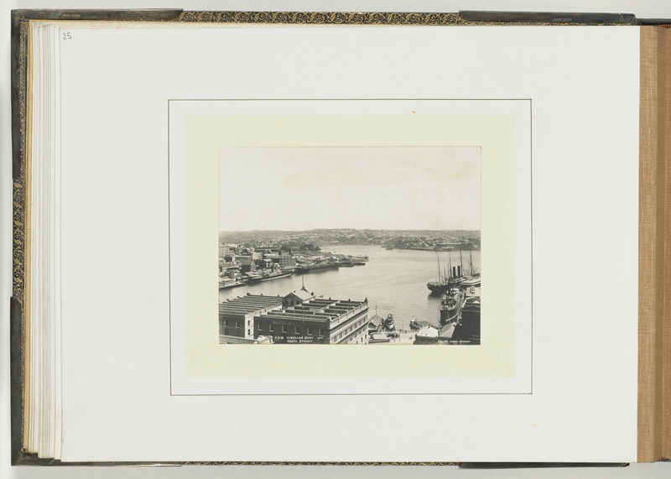
Photo of Circular Quay, Sydney in 1903
http://www.acmssearch.sl.nsw.gov.au/search/itemDetailPaged.cgi?itemID=902396
Source 7
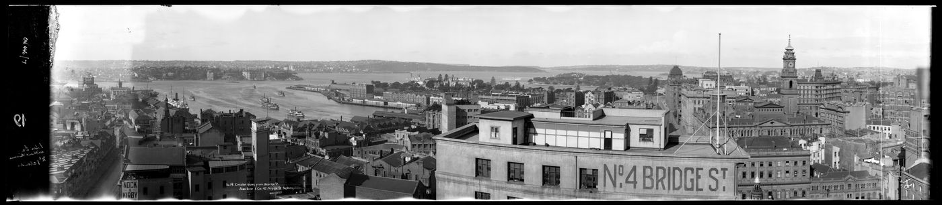
Photo of Circular Quay, Sydney in 1903
http://www.acmssearch.sl.nsw.gov.au/search/itemLarge.cgi?itemID=993154&size=full&album=1&collection=997256

Source 8
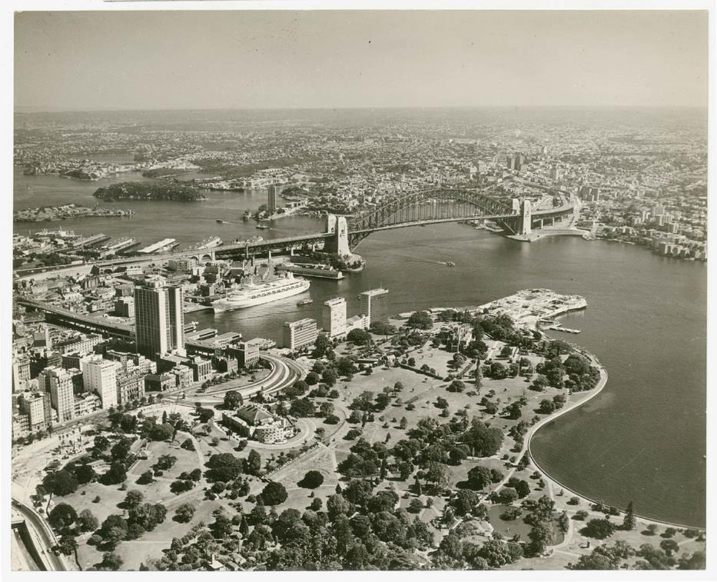
Aerial photo of Sydney in 1954
http://www.acmssearch.sl.nsw.gov.au/search/itemLarge.cgi?itemID=802766&size=full&album=1&collection=823946
Source 9
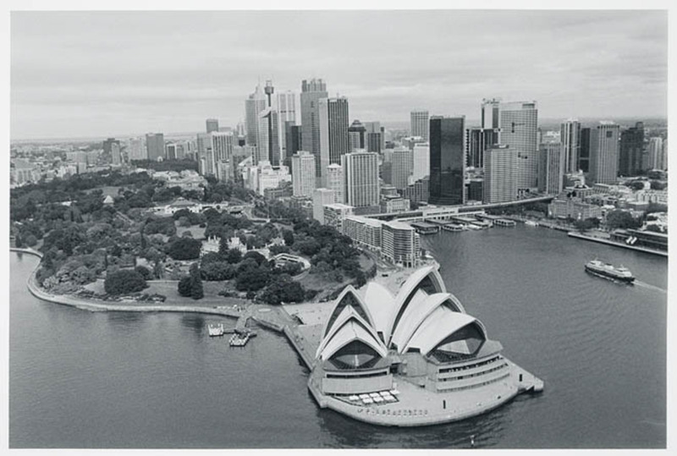
Sydney Harbour, 2002
http://www.acmssearch.sl.nsw.gov.au/search/itemDetailPaged.cgi?itemID=63892

Source | Year | What is similar?  What is different? | What was Sydney like then? Describe its main features.
1 | 1788 | 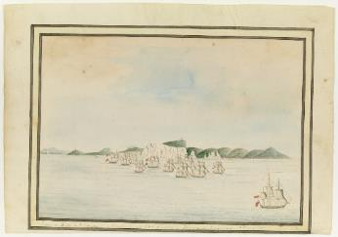
2 | 1804 | 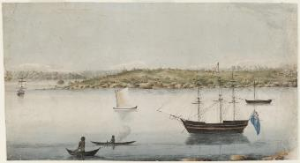
3 | 1825 | 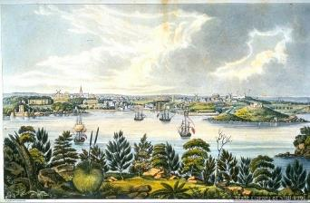
4 | 1842 | 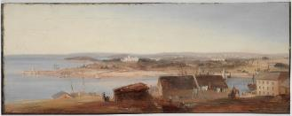
5 | 1892 | 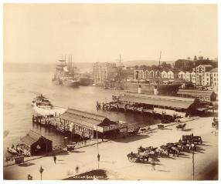
6 | 1903 | 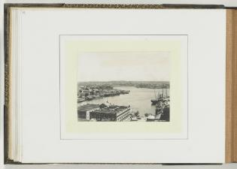
7 | 1920 | 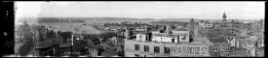
8 | 1954 | 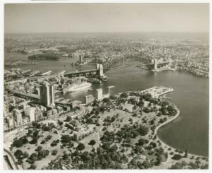
9 | 2002 | 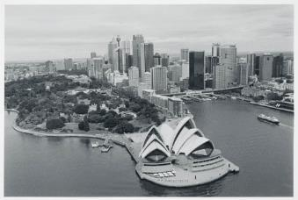
How has Sydney changed since 1788?
Write sentences that describe the differences you identified in the sources.

Background notes for teachers
It is difficult to understand now, but a long time ago the city of Sydney did not exist.
The Cadigal People were the first people to live around the harbour where Sydney now exists. The earliest European painting of ‘Cadi’ (the Aboriginal word for Sydney Cove) in 1788 by the Port Jackson Painter shows a beautiful, thick bush and rock landscape that continued right down to the water’s edge. With the arrival of the First Fleet in January 1788 the entire landscape was changed forever as the convicts and marines chopped down trees and built huts, houses and government buildings around the harbour.
The simple bark huts built by the convicts were soon replaced by brick buildings; wharves were built for the big sailing ships that docked in the harbour and they were replaced by the ferries of Circular Quay; dirt tracks for carts and carriages eventually developed into paved roads and highways.
Today we are surrounded by enormous structures that seem to have always been there. We take for granted that the city of Sydney has massive skyscrapers, The Harbour Bridge and the Opera House. Today we can drive across the harbour in a few minutes on the Harbour Bridge, but until 1932 people had to travel across the harbour by row boat or ferry.
Let’s look at the city of Sydney as it has changed over time. Can you imagine what it might look like 200 years from now?
NSW Syllabus for the Australian Curriculum History K - 10
Outcomes | Historical Skills | Historical concepts
HT1-2 identifies and describes significant people, events, places and sites in the local community over time  HT1-4 demonstrates skills of historical inquiry and communication | Comprehension: chronology, terms and concepts  - use historical terms (ACHHS065, ACHHS082)  Analysis and use of sources  - locate relevant information from sources provided (ACHHS068, ACHHS084, ACHHS215, ACHHS216)  Research  - pose a range of questions about the past (ACHHS067, ACHHS083)  Explanation and communication  - develop texts, particularly narratives  (ACHHS070, ACHHS086)  - use a range of communication forms (oral, graphic, written) and digital technologies (ACHHS071, ACHHS087) | - Continuity and change: some things change over time and some things remain the same  - Cause and effect: events, decisions or developments in the past that produce later actions, results or effects
Learning across the curriculum
- Literacy
- Work and enterprise
- Sustainability

