Geography: People and Places | Stage 1 | Duration: 10 weeks, 3-4 hours per week
Summary
Students explore places across a range of scales within Australia and Australia’s location in the world. Students represent and describe the position of objects on maps and within their local area. They gather, organise and display data on the places people have visited in Australia and examine the factors influencing people’s access to places. They discuss connections people have with places, both locally and globally. Students respond to texts to understand the special connection Aboriginal Peoples have to Country.
Outcomes | Key inquiry questions
Geography K-10  - describes features of places and the connections people have with places GE1-1  - communicates geographical information and uses geographical tools for inquiry GE1-3  Mathematics K-10  - represents and describes the positions of objects in everyday situations and on maps MA1-16MG  - gathers and organises data, displays data in lists, tables and picture graphs, and interprets the results MA1-17SP  English K-10  - plans, composes and reviews a small range of simple texts for a variety of purposes on familiar topics for known readers and viewers EN1-2A  - thinks imaginatively and creatively about familiar topics, ideas and texts when responding to and composing texts EN1-10C  - responds to and composes a range of texts about familiar aspects of the world and their own experiences EN1-11D | Where are places located in Australia?  How are people connected to places?  What factors affect people’s connections to places?
 | Language
  - direction, left and right turns, half turns, full turns
  - pictorial map
  - Australia, states, territories, city, country, globe, earth, suburb
  - Data, graph
  - Connections, location
  - Scale,

Geographical concepts |  |  | Geographical inquiry skills | Geographical tools
The following geographical concepts have been integrated into the unit:  Place: the significance of places and what they are like  Space: the significance of location and spatial distribution, and ways people organise and manage the spaces we live in  Interconnection: no object of geographical study can be viewed in isolation  Scale: the way that geographical phenomena and problems can be examined at different spatial levels |  |  | The following geographical inquiry skills have been integrated into the unit:  Acquiring geographical information  - pose geographical questions (ACHGS007, ACHGS013)  - collect and record geographical data and information, for example, by observing, by interviewing, or using visual representations (ACHGS008, ACHGS014)  Processing geographical information  - represent data by constructing tables, graphs or maps (ACHGS009, ACHGS015)  - draw conclusions based on the interpretation of geographical information sorted into categories (ACHGS010, ACHGS016)  Communicating geographical information  - present findings in a range of communication forms (ACHGS011, ACHGS017)  - reflect on their learning and suggest responses to their findings (ACHGS012, ACHGS018) | The following geographical tools have been integrated into the unit:  Maps - M  - pictorial maps, maps, world map, globe  Fieldwork - F  - observing, collecting and recording data  Graphs and statistics - GS  - tally charts, pictographs, data tables, column graphs  Spatial Technologies - ST  - virtual maps, satellite images  Visual representations - VR  - photographs, illustrations, diagrams, story books, multimedia, web tools
 | Content | Teaching, learning and assessment |  |  | Resources/ Student diversity
 | Australian places  Students investigate places across a range of scales within Australia, for example:  identification that places exist across a range of scales eg personal, local, national  Measurement and Geometry-Position  - Students give and follow directions to familiar locations  - Students describe the path from one location to another on drawings  - Students use a diagram to give simple directions  - Students interpret simple maps of familiar locations and identify the relative positions of key features | Activity 1- Pretest- Assessment for learning  - What is Geography? (group discussion)  - Give children a blank map of Australia and they are to write/draw anything they think they know about Australia- this could be used for their portfolio and then at the end of the unit children can be given the same map to see their development.  Children share and discuss their maps. As a whole class make a KWL chart or a Think, Puzzle, Explore Chart to find out what children know and want to find out:  - What do you think you know about this topic (Australia and where places are located)?  - What questions or puzzles do you have?  - How can you (we) explore this topic?  Inquiry Question: Where are places located in Australia?  Activity 2- Our local area  - children pose questions about their local area such as ‘what is in our local area?’, ‘what is in or around our school?’ Chn brainstorm in groups using a concept map:  Children explore their school or local area making observations of features such as buildings, roads, vegetation etc. F  - collect and record data of the features they observe eg taking photos, listing what they see, recording their route on a simple map GS  - compose visual or digital texts to depict aspects of their journey around the school or the local area VR  Activity 3- Children create a large map of the school using tape on the classroom floor or chalk on the playground or see example below. They could do this as a whole class or in groups. M  Children:  - label areas of the school on the map and locate their classroom  - use the terms ‘left’ and ‘right’ to describe the position of features on the map in relation to their classroom and from the perspective of a different classroom eg the playground is on the left of my classroom  - follow directions, including directions involving turns to the left and right, to move around the map or their school  - direct another student around the map or school using left and right turns, half turns, full turns  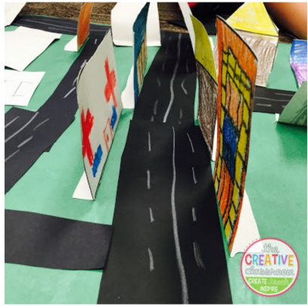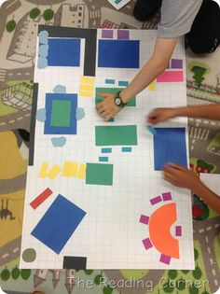  Activity 4- Following Directions  In pairs, children are to record directions to a particular place in the playground without telling their partner the actual destination. (They could place a ‘treasure’ at the final destination) eg. ‘go down the ramp until you get to the toilets and then turn right towards the basketball courts…  Differentiation of content- this task is open ended so encourage children to be quite specific and descriptive when explaining the directions. (they could even work out how many steps they have to take to reach somewhere)  Once recordings are complete their partner has to follow the directions to see if they can find the destination and ‘treasure’.  Assessment of learning  Children are to draw their own map of the playground (eg. below) (children could be given large grid paper for this task)  Objectives:  - to identify where features of the school are located  - describe location and direction using everyday language (past, through, left and arrows)  - represent features of the school & its location on a pictorial map  - Use a drawing and text to share observations |  |  | VisibleThinkingRoutine-Think,puzzle,explore  Making a 3D map  Observations may also include sounds and smells  Collection of data may include:  - prepared checklist  - matching photographs or symbols  - photos or video  Labels can be in words, photographs, symbols or verbal  Directions can be:  - verbal  - written  - pictorial  - in digital form (pre-recorded instructions)  ACARa assessment  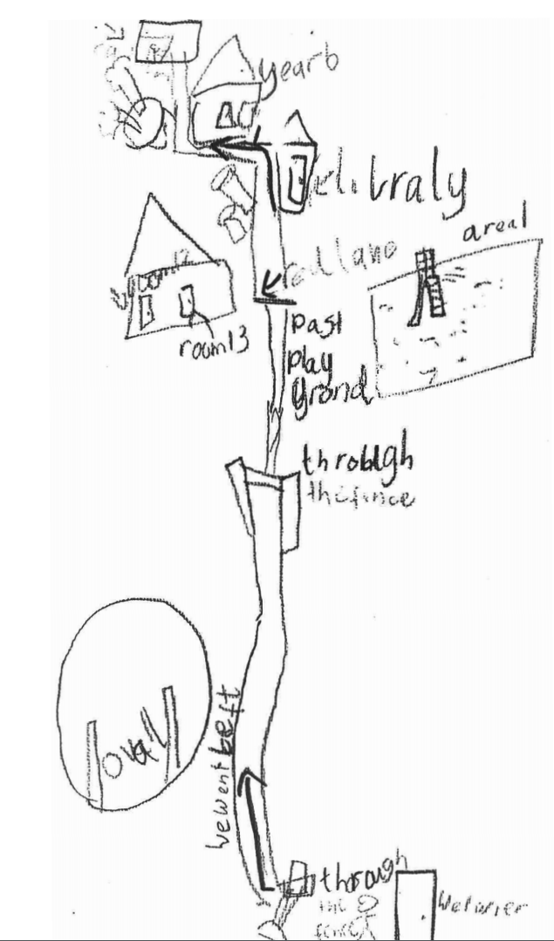
 | Australian places  Students investigate places across a range of scales within Australia, for example:  identification that places exist across a range of scales eg personal, local, national  English  Thinking imaginatively and creatively  Students:  - predict and discuss ideas drawn from picture books and digital stories  Writing and representing 1  Students:  - compose a range of written forms of communication, including emails, greeting cards and letters | Inquiry Question: Where are places located in Australia?  Activity 5-7-Australia is a big place  - Using a stimulus such as Are We There Yet? by Alison Lester students learn about the scale and size of Australia eg local, regional and state areas VR  Engagement and questioning – Australian places  Share the story Are We There Yet by Alison Lester.  - Where do the family live? (Personal scale.)  - Did the family have a personal place as they travelled?  - Where did the family go first? (Local scale.)  - What Australian places did they visit? (National scale.)  - Where would you most like to visit in the book? Why?  - What Australian places have you visited?  Map  Plot the family’s home on a map of Australia.  Differentiation  - Ask how we could map their journey and individually map or contribute to a collaboratively developed classroom map to mark the family’s journey around Australia, identifying specific places, local areas, states and territories M  - Draw a line showing the family’s journey. Label the capital cities and major towns they visited.  Formulating questions for inquiry  - What are places like?  - Where are places located in Australia?  - How do we use scale to define places?  - discuss the family’s journey and the places they visit  - use the map to help describe the events from Are We There Yet? to compose an email, postcard or letter from one of the characters to a school friend back home to explain their journey  Homework: children are to discuss with parents a special place that they have visited and answer some of the questions below. Children can present their homework for NEWS. They could include a map showing the place if they like.  Think, Pair, Share  Using ‘Think, Pair, Share’ children consider their own experience of a journey and respond to questions such as:  - When was your journey?  - Who went on the journey with you?  - Where did you visit?  - What is your favourite type of journey?  - Do all journeys begin and end in the same place?  - Where are your favourite places to visit? |  |  | ‘Are we there yet?’ By Alison Lester  Map of Australia  Labels of ‘me, my house etc’  Some students may benefit from  - viewing the text ahead of the lesson  - a digital copy  - an audio copy  Some students may undertake individual research on the features of one of the places visited in the book  Responses may be oral, written, signed or in symbols.  Some students may benefit from having a question ahead of time to prepare a response  Visible Thinking Routine  Think pair share
 | Local and global connections  Students:  investigate connections that people, including Aboriginal and Torres Strait Islander Peoples, have to local and global places, for example:  - discussion of Aboriginal and Torres Strait Islander Peoples’ connections with land, sea and animals of their place  - description of reasons people are connected to places in Australia and/or countries across the world eg birthplace  Stage 1 - Expressing themselves  Students:  - discuss characters and events in a range of literary texts and share personal responses to these texts, making connections with students' own experiences  People’s connections to places  Students:  investigate people’s connections and access to places, for example:  - discussion of why people visit other places  - identification of factors influencing people’s accessibility to places eg distance  - examination of how technology has improved people’s access to places  Data 1  Students:  Represent data with objects and drawings where one object or drawing represents one data value and describe the displays (ACMSP263)  People’s connections to places  Students:  investigate people’s connections and access to places, for example:  − identification of factors influencing people’s accessibility to places (i.e distance)  − examination of how technology has improved people’s access to places | How are people connected to places?  What factors affect people’s connections to places?  Activity 8-9 - Connections to places  - Children think about places that are important to them because of a special connection they have with the place eg where they live; the town, city or country their family comes from  - Students listen to, and engage with, a local Aboriginal community representative who is able to explain the connection Aboriginal people have to Country, land, sea and sky through examples from the local area  www.aecg.nsw.edu.au  - Using a picture book stimulus, such as In Redfern by Anjelica Gordon, Lyall Munro and Jessica Robinson www.indijreaders.com.au, students discuss: VR  - where the story took place  - how the characters demonstrate their feelings about Country  - verbs used in the text to describe what the character is doing  - Children communicate how their own experiences of connections to places compare with the characters in the book- a Venn diagram could be completed  Homework: children (with parent help) can bring in photographs, drawings and information about places they have visited such as a park, church, holiday and share with the class  - Children share information about places they visit eg school, park, sports club, religious place, overseas countries and discuss:  - why they visit these places  - reasons why they may feel connected to these places  - how often they visit these places eg daily, every week GS  - how they get to these places eg walk, car, public transport VR  Children interview each other to gather information about places people have visited. They display the data collected using drawings, symbols or photographs. GS VR They:  - describe the information using comparative language such as ‘more than’ and ‘less than’ eg more students go to the park than the swimming pool  - interpret the information to identify factors influencing people’s accessibility to places such as distance eg. more people have visited Queensland because it is closer to NSW  Children work together to:  - develop ideas about why people need access to other places eg. visit relatives and friends, to work, for holidays  - identify how people access other places eg cars, trains, planes, telephones, internet ST  - draw conclusions about how transport and technology have helped people access places eg getting people to their work places, assisting people with a disability, communicating with people in other places  - Children reflect on their learning to create a display summarising how transport and technology help people to access local and distant places VR  - Follow the State Library program called |  |  | Children can participate in discussion using speech, sign, gesture, symbols or with assistive technology.  In Redfern by Anjelica Gordon, Lyall Munro and Jessica Robinson  Use photographs of actual places  Provide advance notice to student/family to prepare photographs and/or a response in advance for the discussion  Displays could include posters, picture collages, infographics, multimedia presentations, column graphs etc
 | Australia’s location  Students:  investigate Australia’s location in the world, for example:  - description of Australia’s location in relation to the world eg continents, oceans | Australia and the world  Children investigate Australia’s location in the world by comparing world maps, globes and/or online maps M ST  - Differentiation of learning environment, content and process:  HOT: complete map (with more detail) independently or in pairs using an atlas  LOT: some work in groups and/or with greater teacher support.  - Children create their own map identifying: VR  - Australia  - its neighbouring countries  - surrounding oceans eg Pacific, Indian and Southern  - HOT: chn can put in continents, equator and other details  Children are to complete ‘Me on the Map’ (see below)  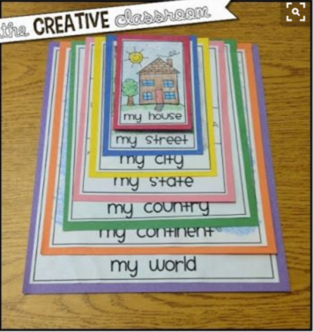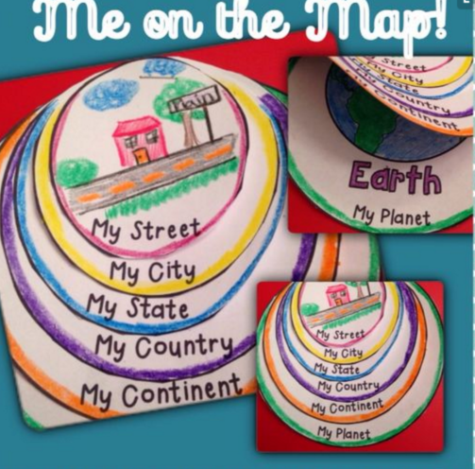  Children:  - identify ways people from overseas can access Australia eg plane, ship, telecommunications  - discuss some advantages and disadvantages of Australia’s location in the world  Using the State Library program below:  http://www.sl.nsw.gov.au/learning/people-and-places-connections-access-transport  investigate people’s connections and access to places, for example:  − identification of factors influencing people’s accessibility to places (i.e distance)  − examination of how technology has improved people’s access to places  Assessment of Learning  Give children a map of Australia and the world. They are to write/draw anything they can remember about Australia. This can go in their portfolio next to the map from the Pretest. |  |  | Map of Australia and the World (see word document)  ‘Me on the Map’ labels (see word document)  Maps may take different forms dependent on the needs and interests of the student:  - pictorial map  - Google Maps  Some students may suggest:  - how visitors from a country neighbouring Australia may travel to Australia,  - places for them to visit and some of the features of places they would see during their journey

Assessment overview
Outcomes assessed: GE1-1, GE1-3
Students are given a stimulus of a familiar place. The stimulus may include an image, video, book or map.
They compose a text in response to the stimulus to illustrate:
- where this place is located
- why people would visit this place
- how they could access this place
- factors that would affect people accessing this place
Texts may include spoken, written, pictorial, multimedia forms.
Resources used:
Assessment: http://www.acara.edu.au/curriculum/worksamples/year_2_geography_portfolio.pdf

State Library programs:
These programs are great:
http://www.sl.nsw.gov.au/learning/people-and-places-connections-access-transport
http://www.sl.nsw.gov.au/learning/people-and-places-australian-places
http://www.sl.nsw.gov.au/learning/people-and-places-visiting-places-holidays

Need to buy Australian map

