Geography: Stage 2 (Years 3 and 4) The Earth’s Environment
Students examine the importance of natural vegetation and natural resources to animals. Students learn what a habitat is.
Topic: | Significance of Environments: Animal Habitats
Key inquiry questions: | - How does the environment support the lives of living things?
Content
Significance of environments
Students:
- investigate the importance of natural vegetation and natural resources to the environment, animals and people, for example: (ACHGK021, ACHGK022, ACHGK024)
- explanation of the importance of natural vegetation to animals and the functioning of the environment (ie. it allows homes andhabitats)

Student Learning Activities
Activity 1: Engagement and questioning – Rainbow lorikeet habitat  Observe  What can you see in the image?  Infer  Which parts of the plant is the animal using?  What is the plant providing for the rainbow lorikeet?  Discuss  What animals have you seen using plants in the school playground?  How were the animals using the plants?  Formulate inquiry questions  What are animal habitats and the elements of habitats?  Where are animal habitats found?  Why are natural vegetation and non-living habitat elements important to animals?  Why care about the interconnections between animals and their habitats? | Source 1: Rainbow lorikeets, natural history and botanical drawings, ca.1849-1872, attributed to Louisa Atkinson  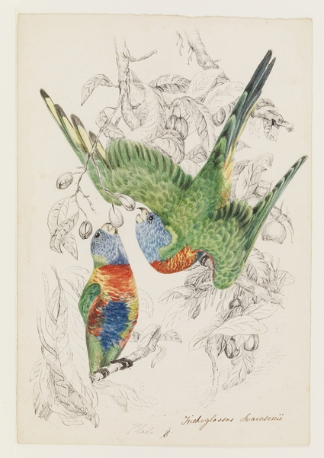  http://www.acmssearch.sl.nsw.gov.au/search/itemDetailPaged.cgi?itemID=446170
Activity 2: Acquiring geographical information – Natural features of a forest
The sketch in Source 2 was drawn by landscape artist Eugene von Guerard whilst exploring Australia in the mid 1800s. Having come from Europe he experienced Australia as a new environment and documented what he saw in detail.
Label the natural features in the image of the open forest in Source 2. Discuss how animals may use these natural features.
Source 2: Moorabul (Moorabool), Victoria, Volume 01: Sketchbook XXII. No. 4 Australia, 29 Feb 1856, by Eugene von Guerard
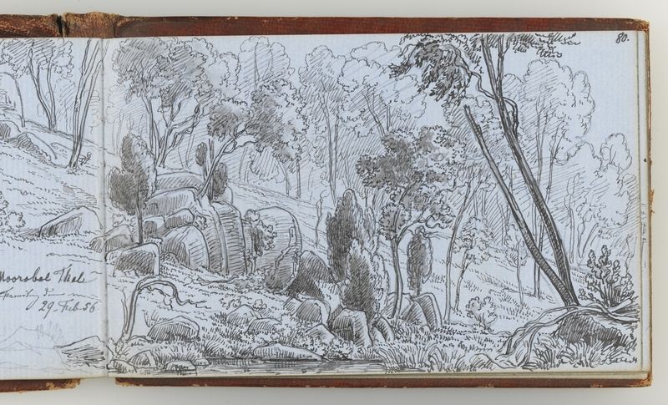 http://www.acmssearch.sl.nsw.gov.au/search/itemDetailPaged.cgi?itemID=824690
Activity 3: Acquiring geographical information – What are animal habitats and the elements of habitats?
Some of the natural features of forests provide habitat for animals. Habitat is place in which an animal lives. It provides the requirements the animal needs for survival including shelter, food and water. Natural environments have many different habitat elements. Natural features that provide habitat for animals can be grouped into living and non-living.
Students view the examples of habitat elements in Sources 3 to 6. They highlight each labeled natural feature in Source 2 that is a habitat element, adding additional labels if needed. As an optional activity, students research the habitat values of each element.
LIVING HABITAT ELEMENTS: Trees, shrubs and groundcover plants
Source 3: Tree – Christmas bush, Australian botanical drawing, late 1700s  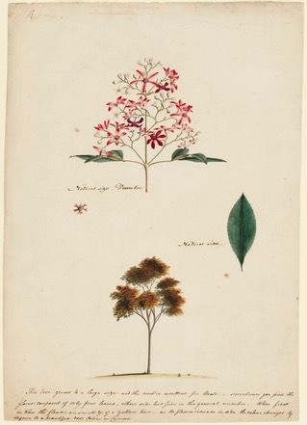  http://www.acmssearch.sl.nsw.gov.au/search/itemDetailPaged.cgi?itemID=88456 | Source 4: Shrub – Hop goodenia, Australian botanical drawing, late 1700s  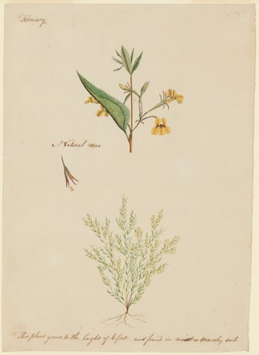  http://www.acmssearch.sl.nsw.gov.au/search/itemDetailPaged.cgi?itemID=88456 | Source 5: Groundcover – (unidentified) Australian botanical drawing, late 1700s  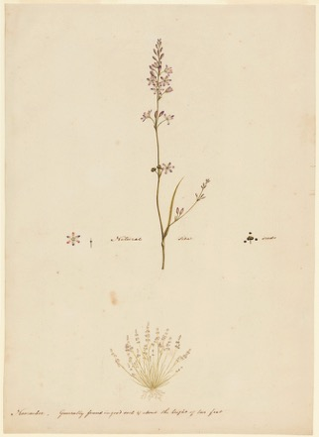  http://www.acmssearch.sl.nsw.gov.au/search/itemDetailPaged.cgi?itemID=88456
NON-LIVING HABITAT ELEMENTS: Leaf litter, water, rocks and logs
Source 6: Rocky waterhole, natural history and botanical drawings, ca.1849-1872, attributed to Louisa Atkinson (Item 4)
Water
Logs
Rocks
Leaf litter
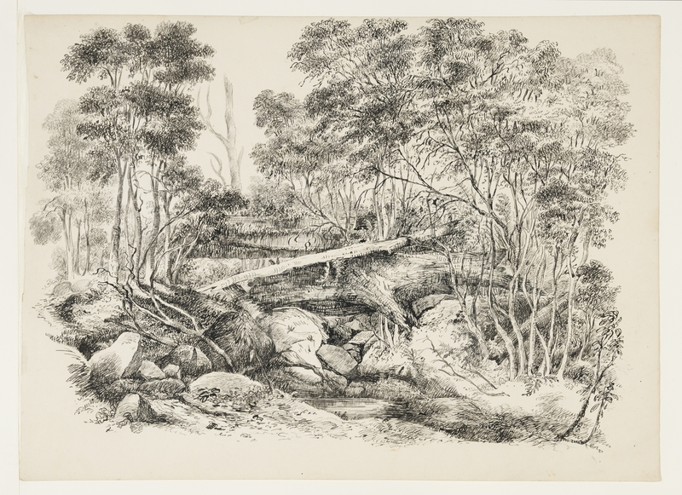
http://www.acmssearch.sl.nsw.gov.au/search/itemDetailPaged.cgi?itemID=446170
What is animal habitat?
List the living and non-living elements of animal habitats.
Activity 4: Representing geographical information – Where are animal habitats found?
Animal habitats are found in all vegetation types (ie. desert, grassland, forest and rainforest. Create a photo sketch of the eucalypt forest below. Label the habitat elements found in this environment).
Source 9: Eucalypt forest, Lane Cove National Park, NSW, photographed by C McGhee
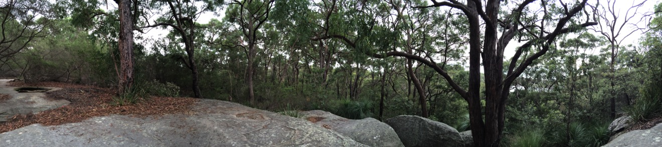
Photo sketch:

What animals might use each of the habitat elements in this forest?
List the habitat elements you labelled and suggest animals that might use them.

Activity 5: Acquiring and processing – Why are natural vegetation and non-living habitat elements important to animals?
View Sources 8 to 19 and identify what the habitat elements in the natural environment provide for each animal. Complete Table 1.
Source 8: Koala, 1803, painting by J W Lewin  Koalas are arboreal, meaning they mainly live in the branches of trees. They eat eucalyptus leaves and very rarely come to the forest floor.  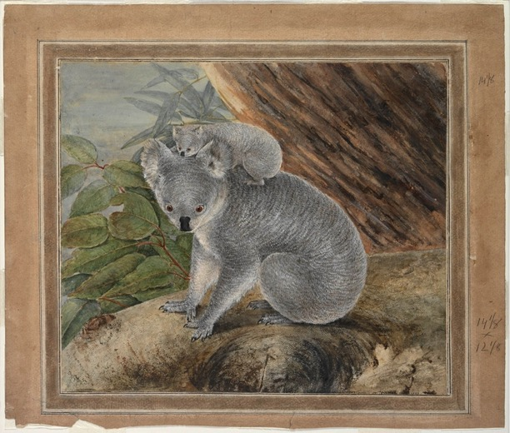  http://www.acmssearch.sl.nsw.gov.au/search/itemDetailPaged.cgi?itemID=421756 | Source 9: Phascogale, ca.1857-1866, watercolour drawing by Gerard Krefft (Item 11)  Phascogales are arboreal carnivores, eating small birds, mammals and insects they find in tree bark and leaf litter. They sometimes eat nectar. They don’t need to drink from a water source as they receive enough moisture from their food.  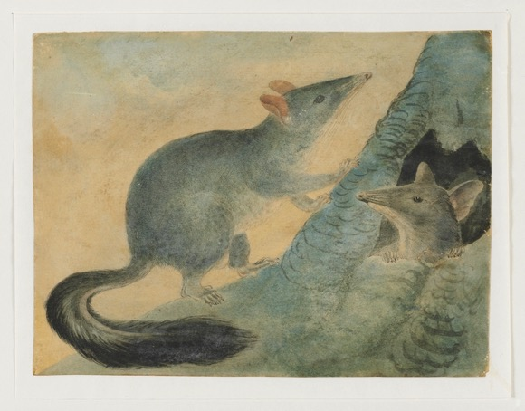  http://www.acmssearch.sl.nsw.gov.au/search/itemDetailPaged.cgi?itemID=63890
Source 10: Kookaburra, 1791-1792, drawings of birds chiefly from Australia (Item 74)  Kookaburras catch invertebrates, reptiles, and sometimes small birds and mammals, by perching on a branch and swooping. They nest in tree hollows or in arboreal termite mounds.  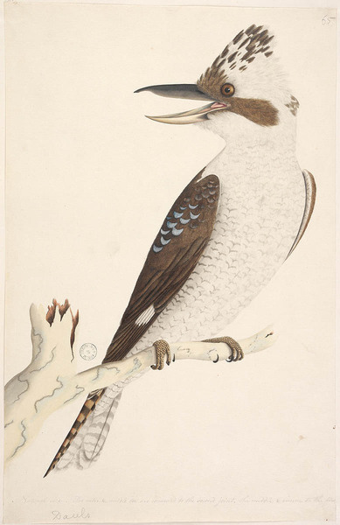  http://www.acmssearch.sl.nsw.gov.au/search/itemDetailPaged.cgi?itemID=440247 | Source 11: Blue-faced honeyeater, ca.1808, by John Eyre  Honeyeaters use their long thin beak to feed on nectar from flowers on trees and shrubs. They also feed on invertebrates.  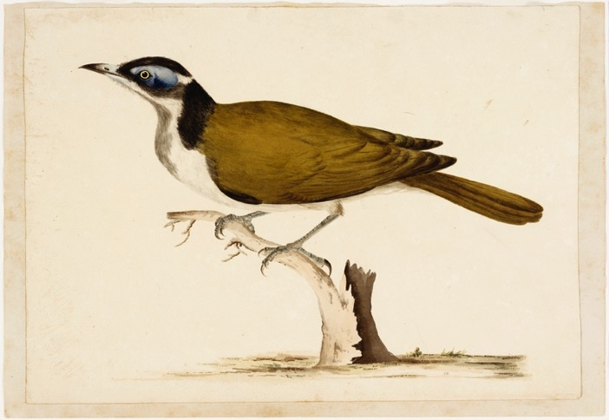  http://www.acmssearch.sl.nsw.gov.au/search/itemDetailPaged.cgi?itemID=142354
Source 12: Rockwarbler, natural history and botanical drawings, ca.1849-1872, attributed to Louisa Atkinson (Item 30)  Usually found around steep rocky gullies near water, rockwarblers feed on insects found around rock crevices and seeds of plants. They build a nest of roots, moss, grass and bark, using spider webs to bind it. The inside is lined with soft materials, including feathers, fur and grasses.  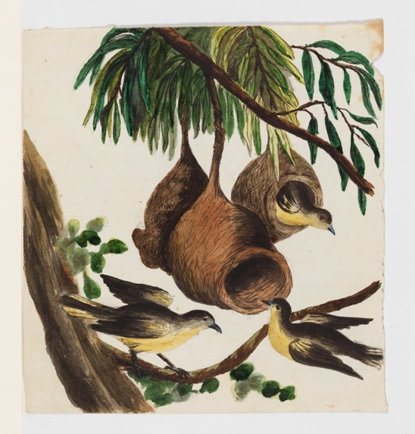  http://www.acmssearch.sl.nsw.gov.au/search/itemDetailPaged.cgi?itemID=446170 | Source 13: Superb blue wren, 1791-1792, drawings of birds chiefly from Australia (Item 33)  Wrens feed on insects on the ground or in shrubs. They need dense, low shrubs in order to find protection from predators.  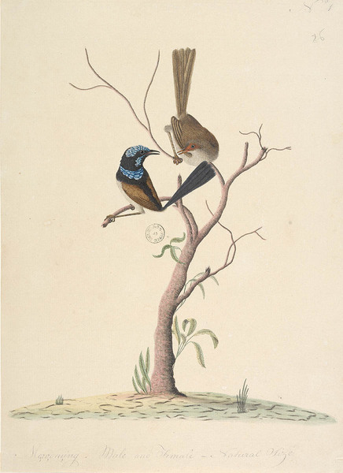  http://www.acmssearch.sl.nsw.gov.au/search/itemDetailPaged.cgi?itemID=440247
Source 14: Pardalotes, Australian paintings, 1796-1809, by J W Lewin, G P Harris, G W Evans and others (Item 40)  Spotted pardalotes forage for insects amongst leaves of trees and shrubs. They often nest in a tunnel built into an earth bank.  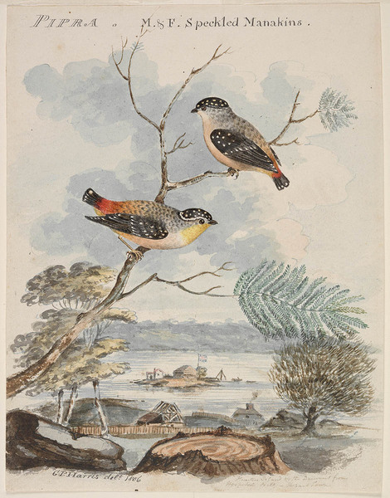  http://www.acmssearch.sl.nsw.gov.au/search/itemDetailPaged.cgi?itemID=447948 | Source 15: Quail, Australian paintings, 1796-1809, by J W Lewin, G P Harris, G W Evans and others (Item 42)  Brown quail live on the edge of forests amongst grass and bracken ferns, feeding on seeds, green shoots and insects.  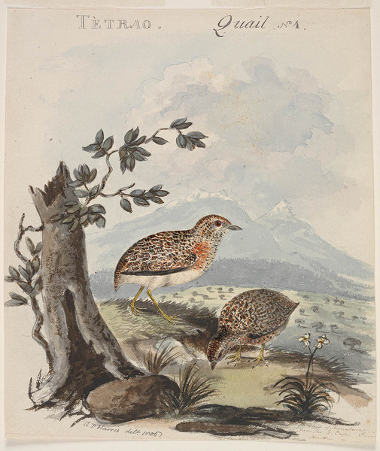  http://www.acmssearch.sl.nsw.gov.au/search/itemDetailPaged.cgi?itemID=447948
Source 16: Blue-tongued lizard, Australian fauna c.1790 by Sarah Stone (Item 12)  By night blue tongue lizards shelter amongst rocks and logs on the ground. By day they can be found foraging amongst grasses and leaf-litter for snails and beetles, or basking in the sun.  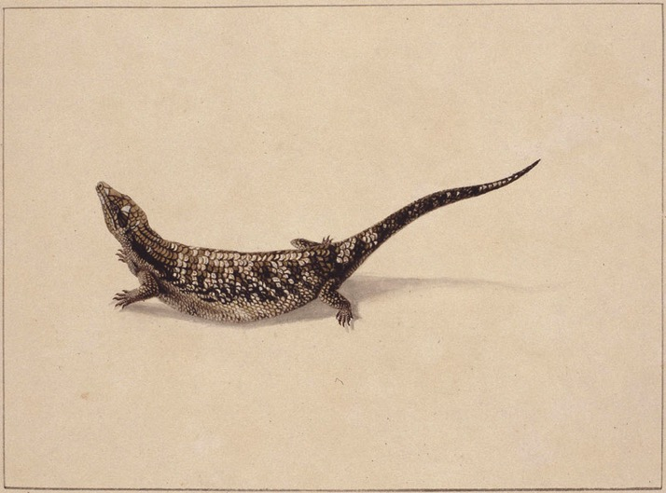  http://www.acmssearch.sl.nsw.gov.au/search/itemDetailPaged.cgi?itemID=411811 | Source 17: Grey teal duck, Zoology of New Holland (Item 83)  Water birds such as native ducks need a permanent source of water to breed and forage for food. They eat land and aquatic plants and aquatic invertebrates.  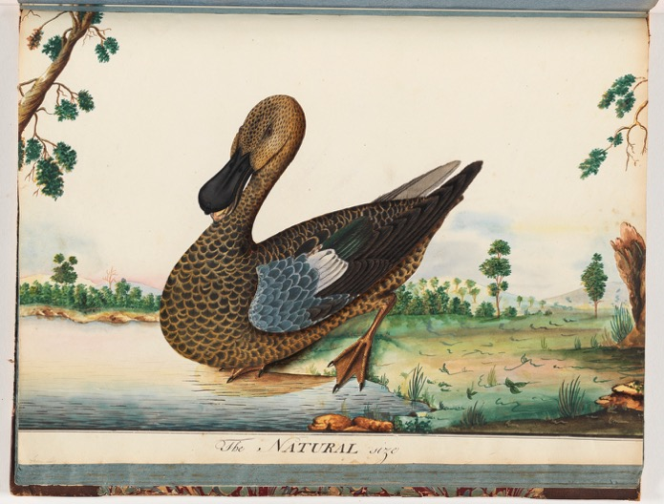  http://www.acmssearch.sl.nsw.gov.au/search/itemDetailPaged.cgi?itemID=940936

Source 18: Brush turkey, 1809, by J W Lewin  Brush turkeys scratch in the leaf litter looking for invertebrates to eat. The males build a large mound of leaf litter to incubate eggs.  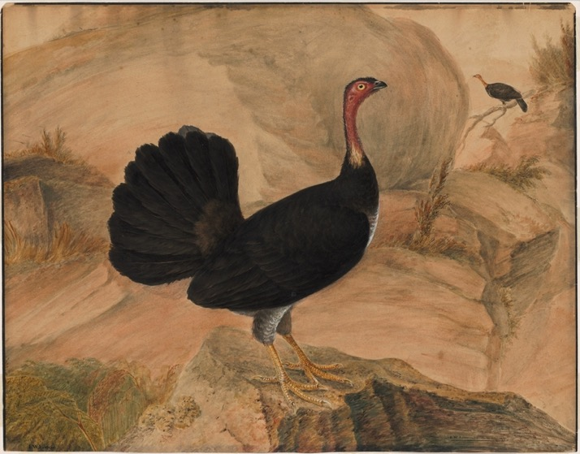  http://www.acmssearch.sl.nsw.gov.au/search/itemDetailPaged.cgi?itemID=446147 | Source 19: Invertebrates of NSW, Australian fauna c.1790 by Sarah Stone (Item 11)  An abundance of invertebrates can be found living under rocks and logs on the ground and amongst the leaf litter on the forest floor.  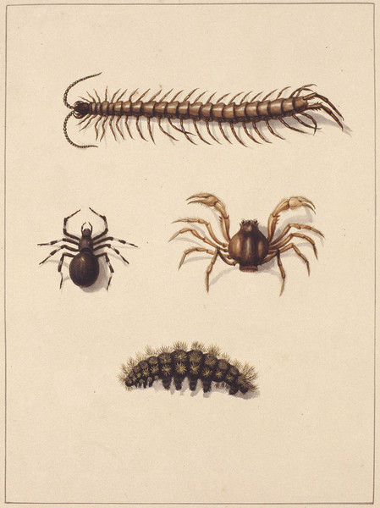  http://www.acmssearch.sl.nsw.gov.au/search/itemDetailPaged.cgi?itemID=411811
TABLE 1 – IMPORTANCE OF ENVIRONMENT TO ANIMALS
Explain how each habitat element is important to the Australian animals in Sources 8 to 19. | 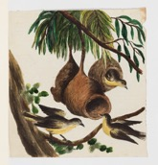 | 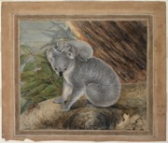 | 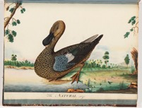 | 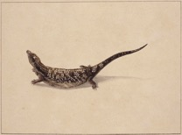
Trees | Makes grass nests in trees
Flowering shrubs
Grasses/groundcovers | Collects nesting materials, eats seeds
Rocks/logs
Leaf litter | Hunts insects to eat
Creek, lake or river | Water to drink

TABLE 1 cont. – IMPORTANCE OF ENVIRONMENT TO ANIMALS
Explain how each habitat element is important to the Australian animals in Sources 8 to 18. | 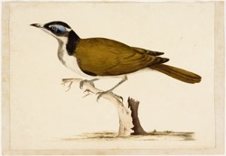 | 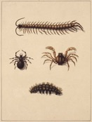 | 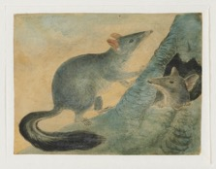 | 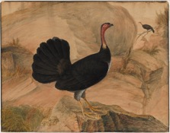
Trees
Flowering shrubs
Grasses/groundcovers
Rocks/logs
Leaf litter
Creek, lake or river

Activity 6: Processing information – Stop habitat removal: Interconnections between animals and their habitats
Imagine that the local council is proposing to give permission to a developer to remove a local eucalypt forest and build a new shopping mall. (There may be a local bushland area to refer to as a hypothetical proposal.)
Using the information collated in Table 1, students list the habitat elements that might be found in the eucalypt forest and explain how the animals rely on each element in the environment. This could be written using persuasive devices that seek to prevent the destruction of the forest.
Activity 7: Communicating – Why care? Design a habitat garden
Imagine that the council has decided to go ahead with the mall but has agreed to put in a habitat garden at the back of the building by planting trees and adding other habitat elements.
Students design a habitat garden. They demonstrate their understandings about habitat elements and the interconnections between animals and their habitats.
Students indicate which animals might be able to visit to use each of the habitat elements in the habitat garden.

Background notes for teachers
Particular natural features in a forest environment provide elements of habitat for animals. This learning sequence focuses on trees, shrubs and groundcover plants as examples of important living habitat elements, and on leaf litter, water and rocks and logs as examples of non-living habitat elements.
Animals often rely on several habitat elements within an environment. For example superb wrens shelter amongst shrubs, forage for invertebrates amongst the leaf litter and shrubs, and need a fresh source of water. Some animals particularly rely on one habitat element and could not survive without it in an environment. For example rainbow lorikeets breed in tree hollows, usually found in mature gum trees.
Interconnections between the environment and animals links with Stage 2 Science – Living World strand, in particular, “Living things, including plants and animals, depend on each other and the environment to survive. (ACSSU073)”. Students could undertake a scientific investigation such as a leaf litter hunt to investigate the diversity of living things found in their school environment and the relationship between plants and animals.

NSW Syllabus for the Australian Curriculum Geography K–6
Outcomes | Geographical Inquiry Skills | Geographical Concepts
GE2-2 describes the ways people, places and environments interact  GE2-4 acquires and communicates geographical information using geographical tools for inquiry | Acquiring geographical information  - develop geographical questions to investigate (ACHGS019, ACHGS026)  - collect and record relevant geographical data and information, for example, by observing, by interviewing, conducting surveys, or using maps, visual representations, the media or the internet (ACHGS020, ACHGS027)  Processing geographical information  - represent data by constructing tables, graphs and maps (ACHGS021, ACHGS028)  - represent information by constructing large-scale maps that conform to cartographic conventions, using spatial technologies as appropriate (ACHGS022, ACHGS029)  - interpret geographical data to identify distributions and patterns and draw conclusions (ACHGS023, ACHGS030)  Communicating geographical information  - present findings in a range of communication forms, for example, written, oral, digital, graphic, tabular and visual, and use geographical terminology (ACHGS024, ACHGS031)  - reflect on their learning to propose individual action in response to a contemporary geographical challenge and identify the expected effects of the proposal (ACHGS025, ACHGS032) | Place: the significance of places and what they are like (ie.natural and human features and characteristics of different places and their similarities and differences; how people’s perceptions about places influence their responses and actions to protect them).  Space: the significance of location and spatial distribution, and ways people organise and manage spaces that we live in (ie.settlement patterns within Australia, neighbouring countries and other countries).  Environment: the significance of the environment in human life, and the important interrelationships between humans and the environment(ie. how climate and environment influence settlement patterns; interconnections between people and environments; differing ways people can use environments sustainably).  Interconnection: no object of geographical study can be viewed in isolation (ie. interconnections between people, places and environments; influence of people’s values on the management and protection of places and environments and the custodial responsibilities of Aboriginal and Torres Strait Islander Peoples).  Scale: the way that geographical phenomena and problems can be examined at different spatial levels(ie. types of settlement across a range of scales; the influence of climate across a range of scales).  Sustainability: the capacity of the environment to continue to support our lives and the lives of other living creatures into the future (ieways in which people, including Aboriginal and Torres Strait Islander Peoples, use and protect natural resources; differing views about environmental sustainability; sustainable management of waste).
Learning across the curriculum
- Sustainability
- Critical and creative thinking
- Literacy
- Civics and citizenship
- Difference and diversity
Resources
Picture books
The Hunt by Narelle Oliver
Leaf Litter by Rachel Tonkin
The Bushwalk by Sandra Kendall
iBook
Habitat Multi Touch iBook https://itunes.apple.com/WebObjects/MZStore.woa/wa/viewMultiRoom?mt=11&at=10lGCa&ls=1&fcId=989692225
Websites
Australian Museum http://australianmuseum.net.au/animals
Birds in Backyards http://www.birdsinbackyards.net

