Is it a Primary or Secondary Source?

My friends and I found an old wedding dress in our attic. My father said it belonged to my grandmother. What is the dress?

At school we use textbooks to learn about the history of the United States. When we use textbooks, what are we using?

I found a letter to one of my friends in the locker room after school the other day. I know it’s private, but I want to read it! What is the letter?

My friend Tim said I should read a book that he really liked. He told me about it—it sounds really good! When Tim talks about the book, what is he?

When I was at summer camp a few years ago, I found a spear; I did some research and found out it was made by Aborigines. What is my spear?

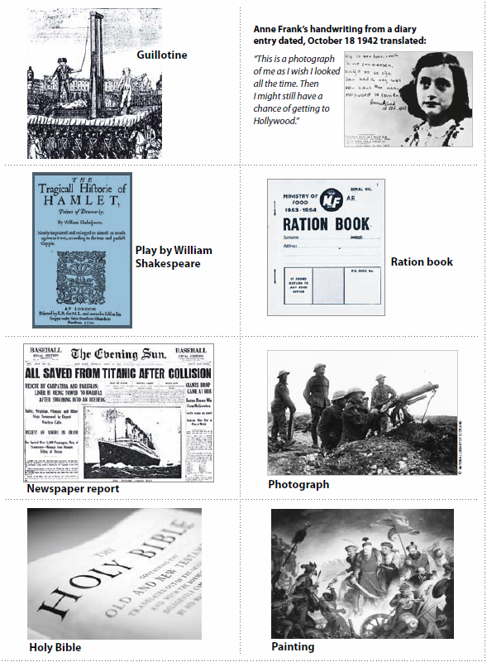

Exit tickets Name: ____________________
Exit Ticket Directions: Complete and hand to the teacher at the end of the lesson.
A primary source is:

__________________________________________________________________
What is an example of a primary source that you have used or you have created?

A secondary source is:

_____________________________________________________________ _____
What is an example of a secondary source that you have used or you have created?

Exit tickets Name: ____________________
Exit Ticket Directions: Complete and hand to the teacher at the end of the lesson.
A primary source is:

__________________________________________________________________
What is an example of a primary source that you have used or you have created?

A secondary source is:

_____________________________________________________________ _____
What is an example of a secondary source that you have used or you have created?

