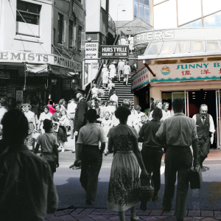

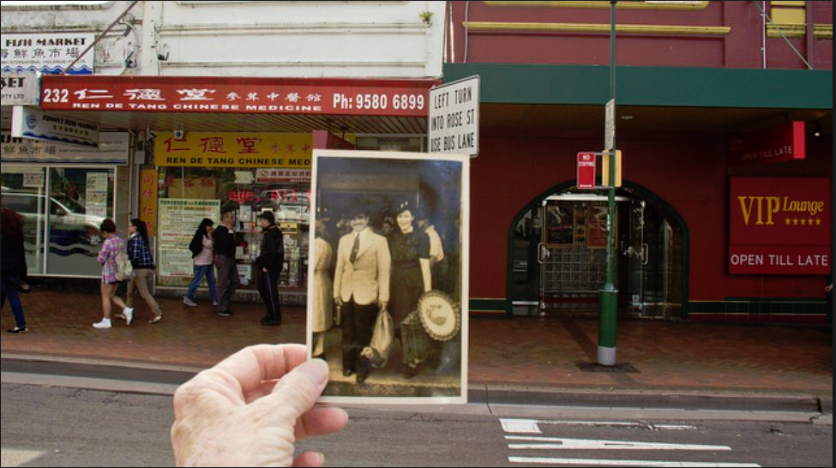 Mum and Dad Forest Road Hurstville Xmas 1944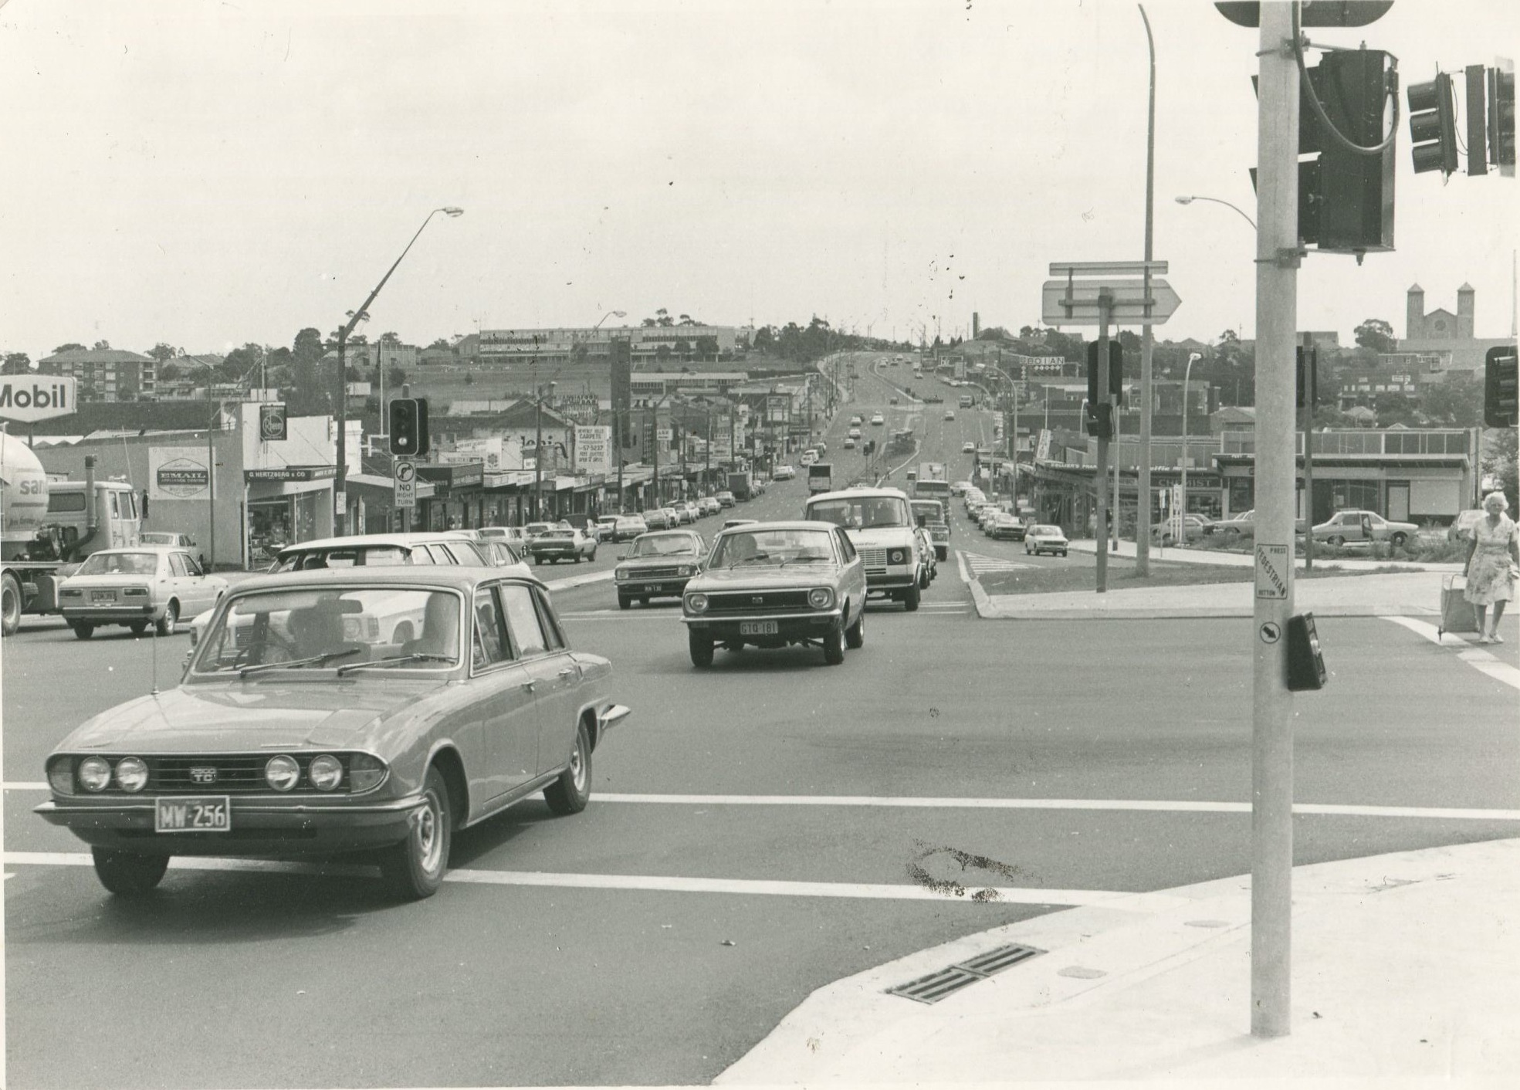 Intersection of King Georges Road and Stoney Creek Road, Beverly Hills, 1981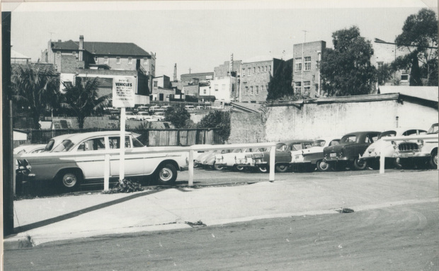
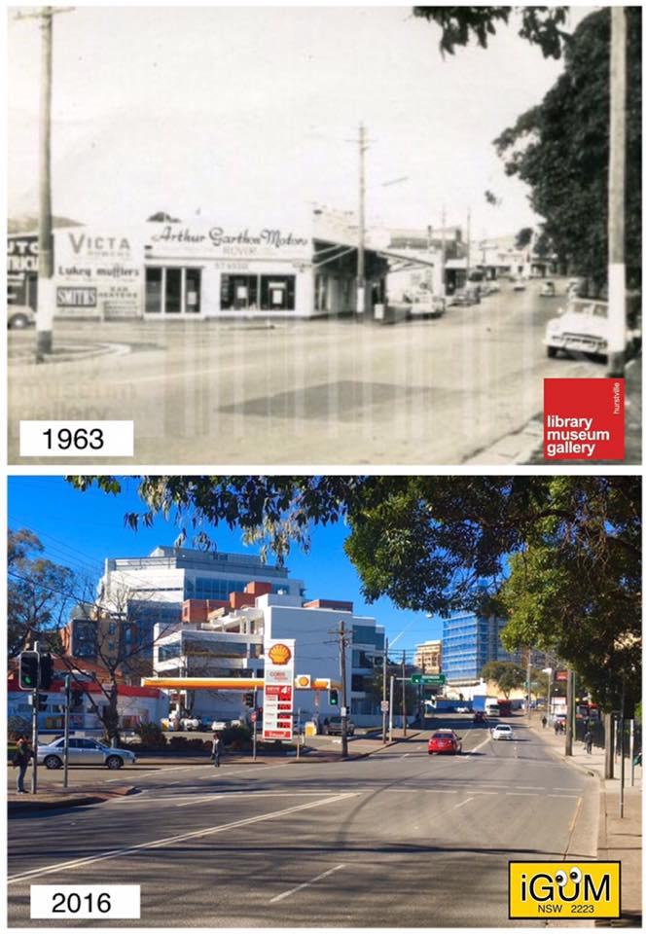 410 Forest Road, Hurstville in 1963 and 2016
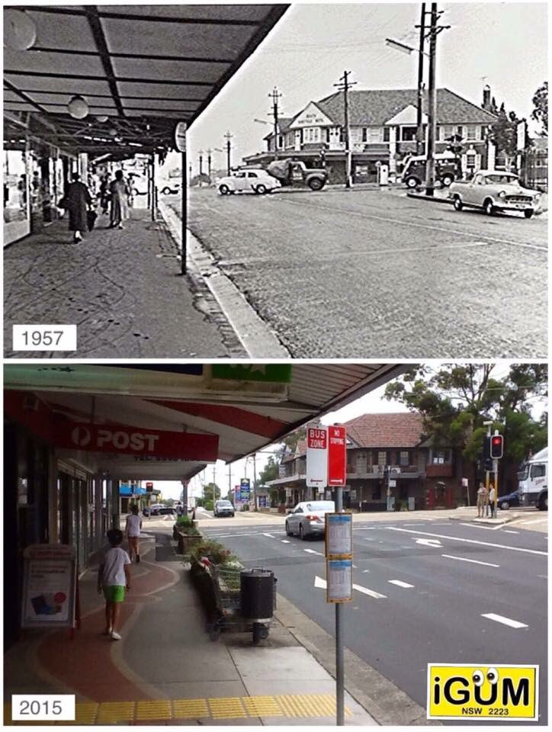
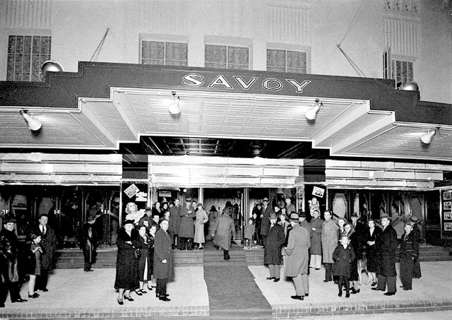 Hurstville Savoy-Mecca

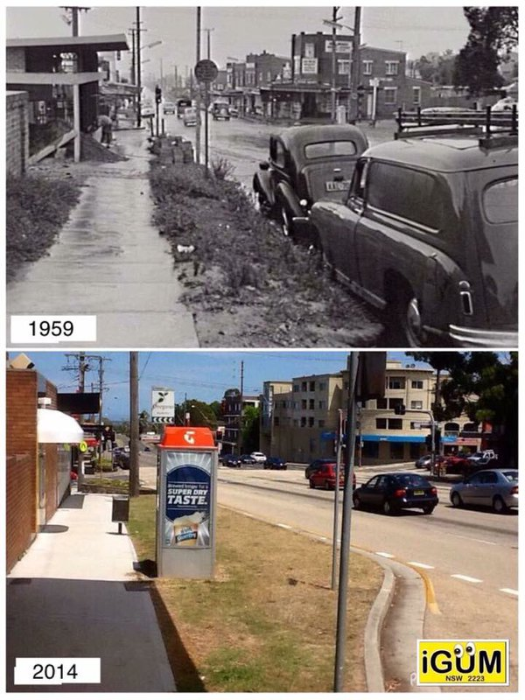
King Georges Road South Hurstville 1959 and 2014
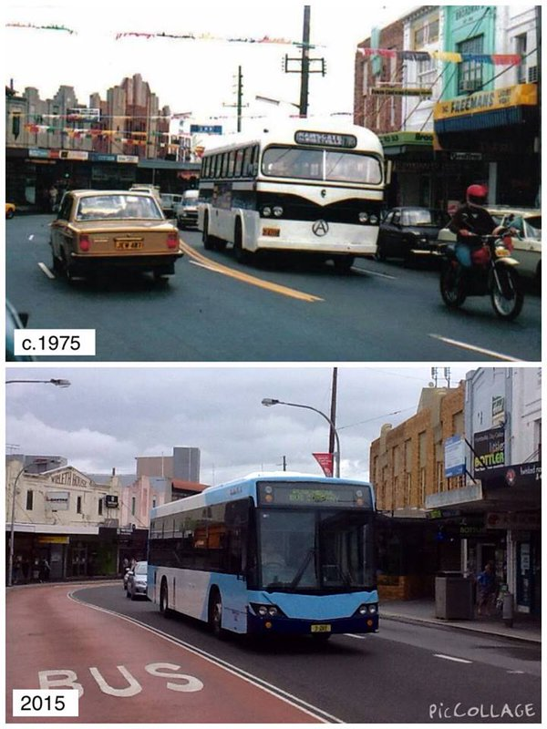
Forest Rd near MacMahon St Hurstville c1975>2015
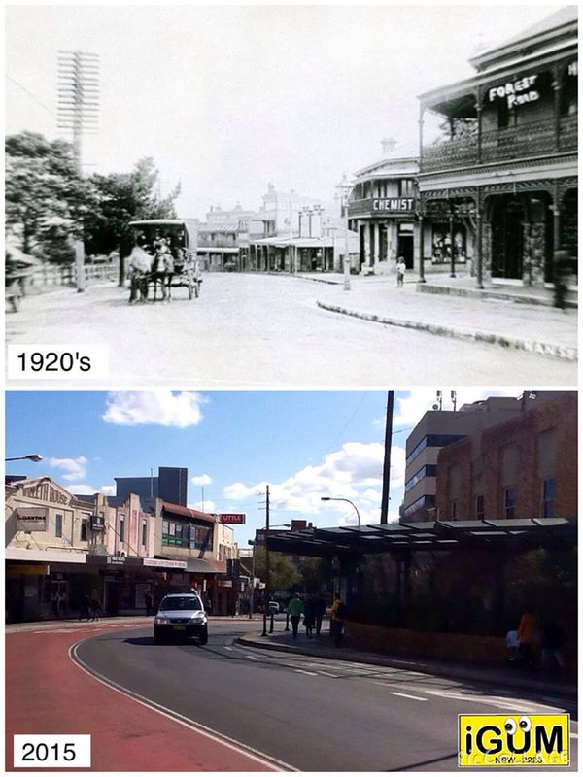
Forest Road Hurstville in the 1920's and 2015
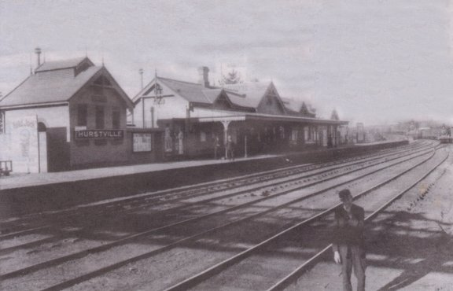 On the 22nd October 1840 the firtst train arrived at Hurstville. At that time the population was 153, I guess it seemed like the back of Bourke.
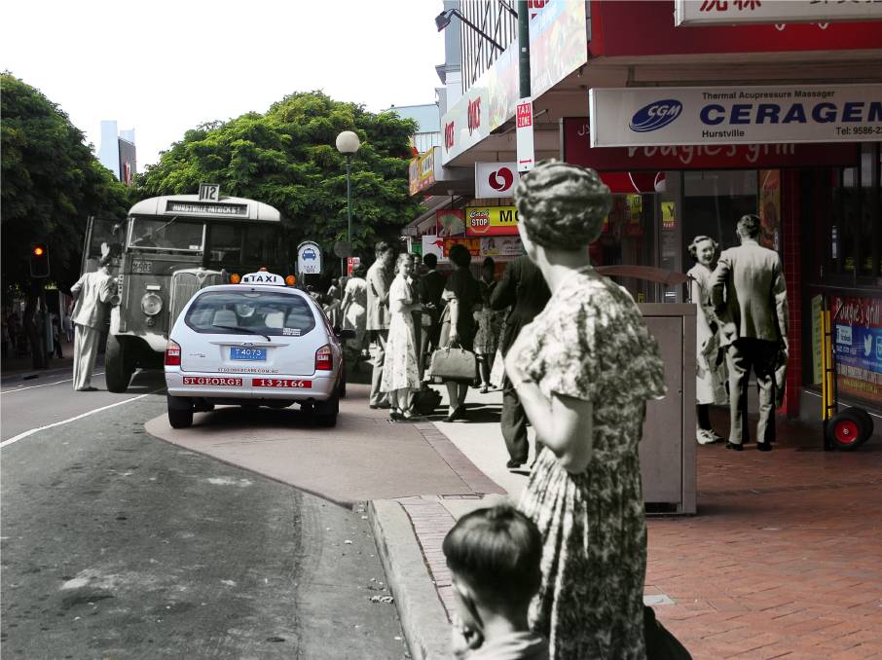 Old and new combined: Forest Road, Hurstville, in 1952 and 2015 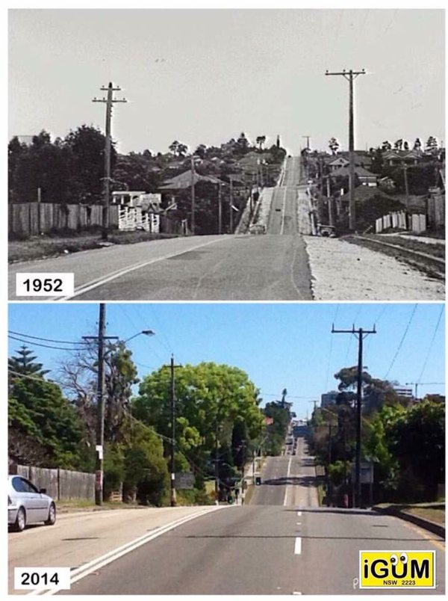
King George's Rd South Hurstville in 1952 and 2014g George's Rd South Hurstville in 1952 and 2014 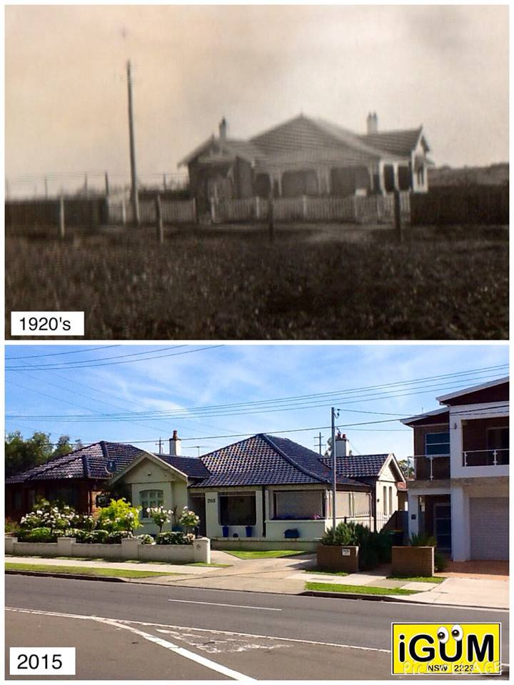
Skilts' 205 Croydon Road, Hurstville in the 1920's and 2015
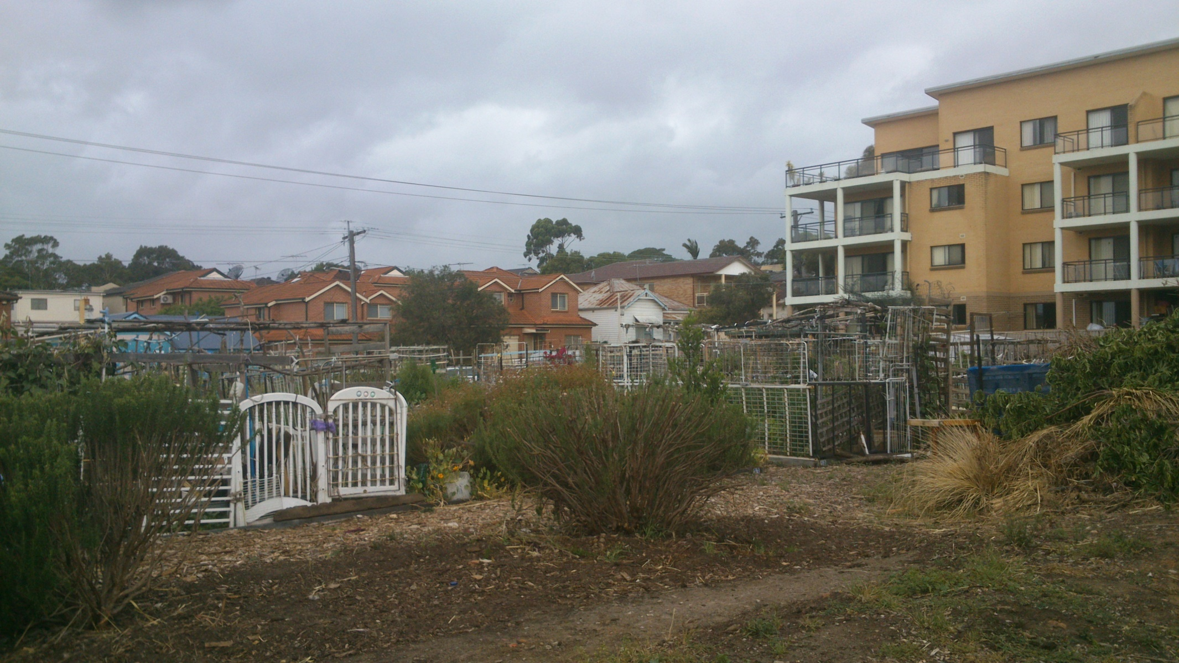
Former bowling club grounds at Hurstville, now a thriving vege patch
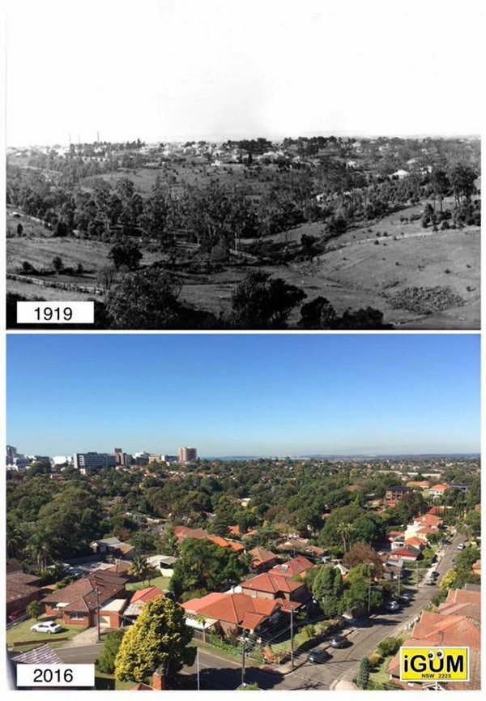
Aerial view of Penshurst & Hurstville in 1909 and 201
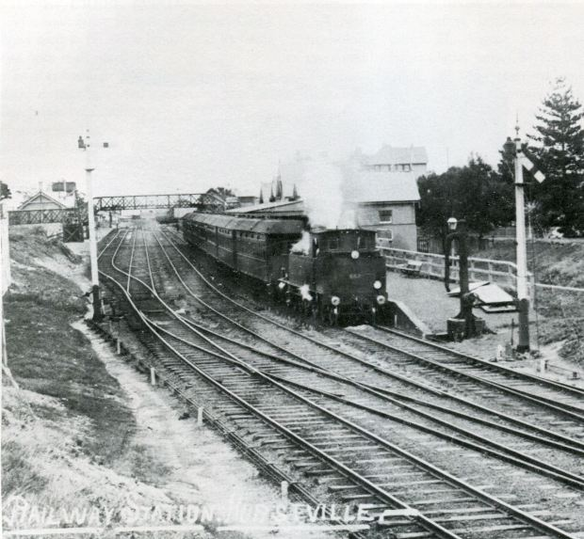Hurstville Station 1910
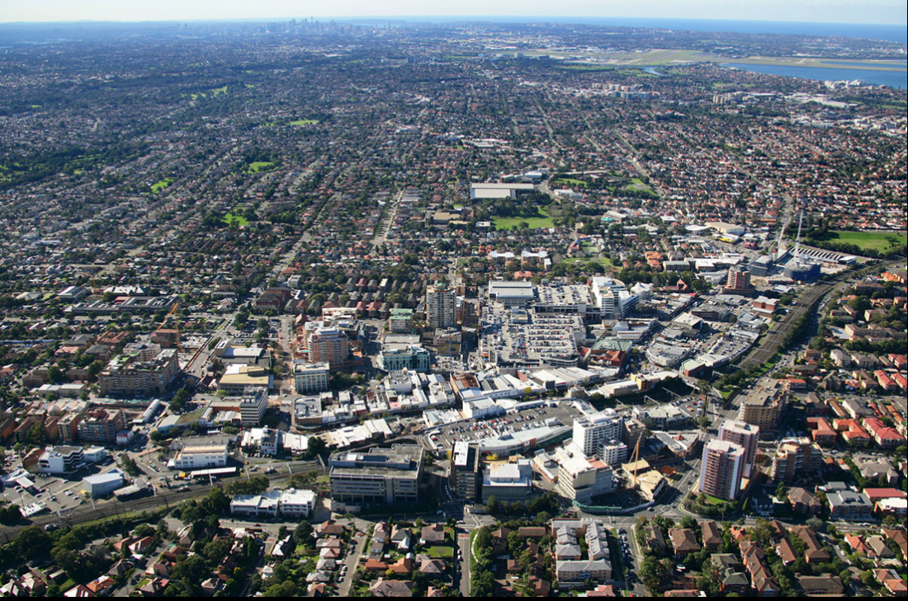Hurstville 2015
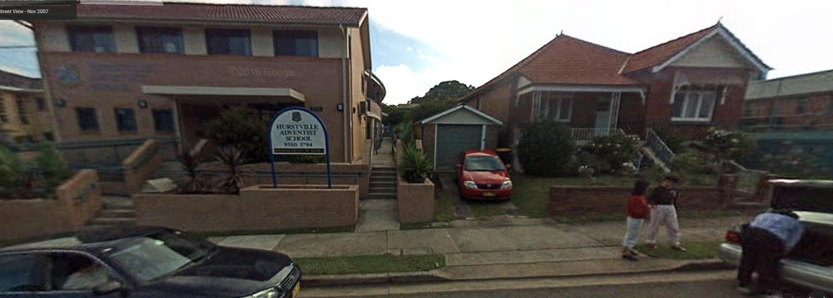Hurstville Adventist School 2007
https://www.google.com.au/maps/@-33.9650826,151.1088192,3a,75y,56.35h,78.53t/data=!3m6!1e1!3m4!1sjygW_7nevm0cCY3WneUTqw!2e0!7i3328!8i1664!6m1!1e1?hl=en&authuser=0
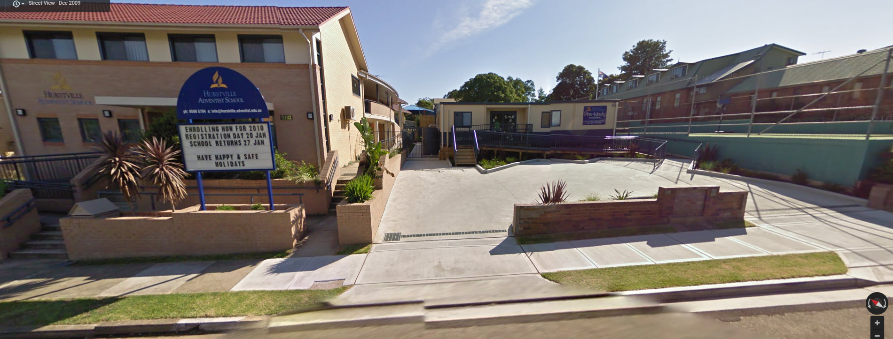
Hurstville Adventist 2009
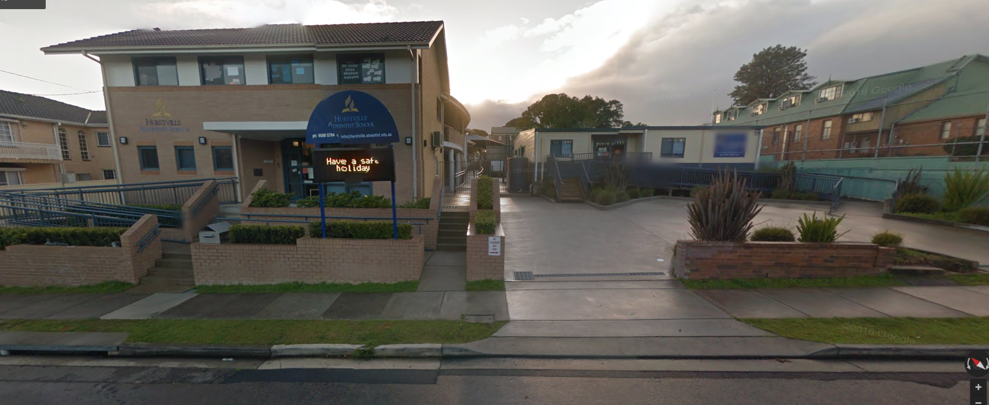
Hurstville Adventist 2015

