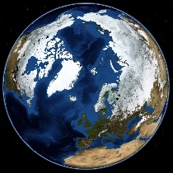
Atlas (before looking at the atlas) Name: ____________
- What might you use an atlas for?
____________________________________________________________________________________________________________________________________________________________________________________________________________________________________
- How would you find a map of Australia in the atlas?
__________________________________________________________________________________________________________________
- I would like to know where Zimbabwe is in the world. How would I go about finding this out?
__________________________________________________________________________________________________________________
Atlas (after looking at the atlas)
- What might you use an atlas for?
____________________________________________________________________________________________________________________________________________________________________________________________________________________________________
- How would you find a map of Australia in the atlas?
__________________________________________________________________________________________________________________
- I would like to know where Zimbabwe is in the world. How would I go about finding this out?
__________________________________________________________________________________________________________________

